Technical Basis of the victorian Residential Efficiency Scorecard – version 1
January 2018

Tony Isaacs
Tony Isaacs Consulting | 31 Donald Street Brunswick 3056 VIC | 03 9386 0700 | 0422674 840
TICONSULT@HOTMAIL.COM | TONY.TICONSULT@GMAIL.COM
Contents
1 Executive summary 4
2 Purpose of the Scorecard tool 4
2.1 The Scorecard tool addresses consumer needs 4
2.2 Technical development and field testing 5
2.3 Key principles 6
2.3.1 Assessment data criteria 7
3 Scope of the Scorecard tool 9
3.1 Building fabric 9
Figure 1: Energy bills split by source 10
3.2 Fixed appliances 10
3.3 Renewable energy 11
3.4 Other features 12
3.5 Star band development 13
Figure 2: Scorecard star rating 13
3.5.1 Market research and learning from international schemes 13
3.5.2 Use of total energy cost as the preferred star band metric 14
3.5.3 Energy cost 14
3.5.4 Development of star bands using a stock model of Victorian household fixed appliance energy use 14
3.5.5 Development of star rating scale 15
Figure 3: Scorecard star ratings for representative housing stock in the Melbourne coastal climate 16
3.5.6 Impact of using a total cost metric on the ratings of large houses 16
Table 1: Large house Scorecard star rating upgrade options 17
3.6 Hot weather rating scale 17
3.7 Home feature rating scales 18
3.8 Consistent approach to NatHERS ratings for building fabric 19
Figure 4: Comparison with Scorecard star rating and NatHERS Star rating for the Melbourne climate zone 20
4 Development of the building fabric model 20
4.1 Need for a simplified building fabric model 20
4.2 How accurate do building fabric loads need to be? 21
Table 2: Building fabric specifications used in the stock model 22
4.3 Scorecard building fabric model 22
Figure 5: Correlation of Scorecard building fabric load predictions with AccuRate predictions 23
4.4 Climatic influences 25
Table 3: Climate settings [ format tables similarly?] 26
4.5 Aggregation of climates 26
Table 4: Typical allocations of heating and cooling climates for regional areas 27
4.6 Air leakage 27
Figure 6: Comparison of air change rates for the Scorecard and blower door predicted natural air change rates 29
5 User assumptions 29
5.1 Heating and cooling 29
5.1.1 Thermostats 30
5.1.2 Hours of use 30
Figure 7: Occupancy percentages 31
5.2 Hot water 31
5.2.1 Occupancy 32
Figure 9: Occupancy assumptions 32
Table 5: Area and average occupancy 32
5.2.2 Clothes washing 33
Table 6: Clothes washing temperature 33
Table 7: Clothes washing loads 33
5.2.3 Bathing 33
5.2.4 Other hot water use 34
5.3 Lighting 34
5.4 Pools and spas 35
5.5 Photo voltaic panels 35
5.5.1 Export ratio 35
Table 8: Ausgrid export ratios 36
6 Appliance algorithms 36
6.1 Space heating 37
Table 9: Space heating load multipliers 37
Table 10: Distribution losses 38
6.2 Space cooling 38
6.3 Hot water 38
6.3.1 Impact of solar hot water heating panels 39
7 PV systems 39
7.1 Allowance for installation practices 39
8 Non-calculated features 39
9 Bibliography 40
10 Appendix A: Example Scorecard certificate 41
Appendix B: Climate zone allocation 43
Table 11: Designated heating and cooling climate zones 43
Table 12: Allocation of designated climate zones 43

Executive summary
This document describes the purpose of the Victorian Residential Efficiency Scorecard (‘Scorecard’) tool, what it covers, why it covers these features and how it calculates a star rating, from a technical basis.

This document represents the Scorecard tool at point of release in 2017 in Victoria (version 1). Please note that this document focuses on the technical features of the Scorecard tool and assumes a level of knowledge of the Scorecard program and certificate. It is strongly recommended that readers familiarise themselves with the program before reading this document.

The Scorecard tool will continue to be updated, extended and refined over time. These changes will be documented and only occur after consultation and validation. It is important that the tool is supported to allow updates to reflect experience in the field, new products, and to better deliver to its purpose over time. It is also important to balance this need to be responsive to the market with certainty. This ensures that changes to the Scorecard do not unduly affect assessor business models. It also ensures that once a dwelling is rated, the rating does not continually change so that home owners can make upgrade decisions with certainty that these decisions will deliver positive rating outcomes.

Purpose of the Scorecard tool
The Scorecard tool has been developed based on extensive policy analysis, technical development and field testing to ensure that it delivers, efficiently and robustly, a service required by the community. The Scorecard provides important feedback to existing or potential occupants on the energy affordability of the fixed energy uses in a dwelling.

The Scorecard is intended to provide information to householders on energy costs of a house as-built and provides a rating of the extent of overheating in hot weather. This information can be used in many ways; for example, as part of a decision-making process to buy or rent houses and apartments. It can support householders to make decisions on energy efficiency renovations, and communicate the value of an upgrade. Where renovation is not possible the information can provide an understanding of what features in the home drive energy costs, and the householder can consider behavioural actions. In addition, the tool provides householders with a measure of the performance of the home during heat waves with no cooling devices operational. This information is useful because of the impact heat can have on health and mortality.

The Scorecard tool addresses consumer needs
The Scorecard tool has been developed to fill a specific gap – it is designed to assess the energy performance of the fixed elements of an existing home quickly without unduly sacrificing accuracy so that assessments are cost effective. Version one focuses on Victoria. As this tool is a first of its kind in Australia, it has been designed so that it can be readily utilised in other states and territories of Australia with minimal changes. This approach potentially allows for greater consumer recognition and uptake, and larger consumer benefits.

Evaluating the most cost-effective solution to reducing fixed appliance energy costs or improving performance during heatwaves for a particular home is technically demanding. Evaluation requires modelling of a range of complex factors including insulation, orientation, built form, and fixed appliances. Obtaining the data required for the evaluation requires accessing ceiling and underfloor spaces and an understanding of the built form and appliances. This complexity presents a challenge: how can such factors be modelled with sufficient accuracy while still providing an assessment process which meets consumer needs in terms of time and cost?

The majority of householders live in older homes, built before energy standards were in place. If they want to identify how they can best save energy in the home, compare options, address an uncomfortably cold or hot home, and access advice suitable for their specific circumstances, there is no source of reputable information available, even though the evidence shows that such information would be highly valued by householders.

Despite the need for this information, there has been no accepted method of evaluating, rating, and comparing the energy performance of existing homes, either nationally or in Victoria. Nor has there been a single accepted method of identifying cost-effective energy performance upgrades relevant to a particular home, or home performance in hot weather.

The lack of such an accepted assessment approach means that home owners are often unclear on how elements of their home contribute to energy bills, and what they could do to control these costs. While there is a fledgling industry which provides such services, householders have no means to determine if the results are valid. Businesses offering services can be seen to have a vested interest in selling a profitable product line. Government oversight of the assessment approach provides confidence that the service provided is fair, and studies have found consumers value this assurance.

Without a reputable assessment technique, it is difficult for home owners to realise the value of home improvements when they sell or rent a house. This becomes a barrier to implementing energy efficient home improvements because the value proposition is too uncertain to generate a return.
This is also a barrier to developing effective programs for existing homes. The previous lack of an accepted evaluation approach and rating scale means that the current energy performance of existing houses in Victoria is poorly understood. It is also difficult to examine cost effective policy approaches to improving this performance. Several surveys have been undertaken that identify that the public would value the provision of this information.

Technical development and field testing
A key challenge of developing the Scorecard tool is balancing technical accuracy with cost-effective delivery. To support this outcome a range of experts were engaged to develop and test the tool. Tony Isaacs of Tony Isaacs Consulting was the principal consultant.

The principal experts that also developed the technical aspects included:
- Alan Pears, Sustainable Solutions
- Robert Foster, Energy Efficient Strategies
In addition, the following played a significant role in scoping the tool:
- RMIT Centre for Design including Professor Ralph Horne, Dr. Usher Iyer-Raniga and Anna Strempel
- George Wilkenfeld, G Wilkenfeld and Associates.
Development of the Scorecard tool leverages learnings from a broad range of Australian and international tools. Within Australia this includes the NatHERS group of tools, BASIX, NABERS group of tools, Australian Greenhouse Calculator (AGC), Green Loans Calculator, Built Environment Sustainability Scorecard, CSIRO’s Liveability Index (originally developed by LJ Hooker) and Habitat Partners.

Work undertaken on the AGC was directly leveraged in Scorecard development. The AGC allows householders to explore how lifestyle contributes to greenhouse gas emissions. These algorithms were developed by Alan Pears and earlier versions of these algorithms were also used in the development of BASIX, NABERS residential tools and the Green Loans Calculator.

Technical development was followed by several field trials to ensure that data could be gathered accurately, consistently and cost effectively. Focus groups testing was undertaken to develop certificate design including ratings depiction. The Scorecard tool reflects learnings from this analysis.

Key principles
Energy prices have risen sharply in the last decade and energy affordability has become an increasingly important issue for consumers. This consumer interest means that the information the tool provides can be a catalyst to drive improvements in dwelling and appliance energy efficiency to reduce energy costs. However, in order for this information to be effective, the assessment process itself must be consumer friendly. The Scorecard assessment is therefore designed so it can be completed quickly to contain assessment costs and reduce the imposition on the occupant, and with sufficient accuracy to ensure that feedback is useful. These two requirements of speed and accuracy contain a potential conflict: if the assessment is too brief important aspects of the house energy efficiency may be overlooked, but if it is too detailed the cost of the assessment may be a barrier to its use.

Studies have shown comparable information is essential to informing consumers and supporting energy efficiency upgrades. The Scorecard tool is designed to provide accurate and standardised information on existing homes. The tool should therefore provide a comparable overall house energy performance ‘star’ rating. It avoids grouping large numbers of houses at the lowest rating as this disengages householders; where justified, it should be feasible to achieve a higher rating by undertaking upgrades. This approach is supported through the learnings from international schemes and the Low Carbon Living CRC.

Section 3.5.4 shows the projected distribution of star ratings expected in the field based on housing stock energy demand modelling. It shows that the star bands have been designed to ensure that rating results cover the full range of houses and provide viable upgrade paths. While there is some clustering around 3 stars this is only to be expected because, on average, housing stock is fairly poor.

The Scorecard tool also rates the performance of the home in hot weather without air-conditioning. This information is not readily available, and in much of Victoria, current NatHERS overall thermal performance ratings give much greater emphasis to performance in cool weather than in hot weather because heating loads are significantly greater than cooling loads. There is a consumer need to understand home performance in hot weather to improve the liveability and safety of homes in heat waves.

To support action by householders, information is also provided on potentially cost-saving energy performance improvements to address overall energy costs and hot weather performance, which can then be demonstrated in an improved rating. The automated improvement suggestions system identifies upgrades with the highest cost savings in each category (building fabric and each of the appliances), but does not make an estimation of the cost of the upgrade.

The following section discusses ‘asset’ ratings. Systems in the US which assess a house based on fixed appliances and building fabric call this type of rating an ‘asset rating’ because it assesses the potential energy demands of all those items that are sold or leased with the home itself i.e the ‘asset’.

Maintaining a balance between speed of assessment and accuracy has therefore been a key principle in the development of the tool and the scope of the data that it requires.

Assessment data criteria

Fixed in house
The Scorecard tool assesses the total annual energy performance of the major fixed energy uses in a house. It does not cover variable personal behaviour, subjective judgement, or mobile appliances (eg TV, fridge, computers), to ensure that ratings are easily comparable between houses. Non-fixed energy uses are highly variable from house to house, have a much shorter life than building fabric or fixed appliances and are used at the discretion of the occupant. Inclusion of non-fixed energy uses would reduce the comparability of the rating; for example, if a house receives a poor rating because the current occupants have three fridges, welding equipment and five TVs that rating would provide little useful information to future occupants who do not have as many appliances.

Assessing fixed assets also supports the longer-term improvement of buildings in Victoria. Fixed assets often have a relatively long life and are slow to change, and poorly performing assets can affect many households over that life. Assessing and improving these assets can generate long term benefits, reducing energy use and improving the comfort of the building stock.

Fixed assets also often interact in their impact on energy bills and these interactions are complex to assess, so householders have difficulty in understanding how to improve performance.

Assessing non-fixed assets would also create the opportunity to game the rating through temporary connection or removal of appliances. Other policies such as appliance minimum standards and behavioural actions are often the most effective means to manage energy use from these sources.

Impact on energy use
Only those building fabric attributes or appliance features which have a significant impact on energy use are assessed by the Scorecard tool.
Uses which may have a low impact on average may be significant in some houses; for example, lighting is generally a low energy use except where halogen lighting is used, so only details of halogen lighting are collected.

The appliance and building fabric details captured by the Scorecard tool focus on those features common to most houses. This enables the tool to focus on modelling of average homes well, rather than investing in complex modelling of bespoke homes.

Modelling of energy use is based on assumed average occupancy patterns gathered from sources such as the ABS and energy and water utilities.
Discoverability & evidence
The information required to complete the assessment of energy use is based on data that is easy to discover in a timely fashion; for example, where the star rating of an appliance is not known a conservative assumption is made about the appliance’s efficiency.

Where important information is not easily discoverable, or where the householder cannot provide evidence, a set of conservative default values are used. For example, wall insulation is difficult to discover so R values are assumed based on the age of the house and prevailing regulations when the house was built. This guards against assessors making generous assumptions that overstate the efficiency of the house and may unfairly benefit a rating. This method is also important to support assessment repeatability and enable two assessors assessing the same home to reach the same score.

To obtain a better rating for the dwelling the onus is on the householder to provide better objective information, such as plans showing wall insulation or an operating manual for an appliance that allows its model number to be identified for reference with databases of appliance efficiency.

This approach ensures that the assessment can be carried out quickly and does not get bogged down in a lengthy discovery process, particularly for those features which do not have a significant impact on energy use.
Differentiation between houses
If an energy use needs a substantial amount of time to measure on site, but does not add significant differentiation between houses, less data collection and a simpler calculation is all that is justified. For example, the use of flow restrictors on taps can have a significant impact on some kinds of tap hot water use, but it is very hard to accurately measure flow restrictors, and they have little impact on some kinds of water use (such as filling baths), so the assessor is not required to enter information about tap flow restrictors, only flow rates in showers.
Compatibility with other schemes
Where possible, the Scorecard tool leverages information from other schemes to minimise data input. Appliance star ratings are used as a measure of efficiency, Minimum Energy Performance Standards (MEPS) provide guidance on default appliance efficiency where no star rating can be discovered. Occupant energy use assumptions are generally consistent with white certificate schemes like Victorian Energy Upgrades (previously known as VEET). Heating and cooling load information from NatHERS tools will be able to be integrated into the Scorecard tool in future.
Provide recommendations for upgrades
The Scorecard tool provides information on the benefit of upgrades specific to the building fabric and appliance mix of a house. This is currently a gap in the market as this information is not provided in more general information resources and white certificate schemes often assume the same benefit for upgrades independent of the house and appliance features. This is important as the intention of the tool is to drive improvements in dwelling energy efficiency. There is limited value in including an energy use if it does not have scope to be improved (e.g. gas cooktop), so fixed energy uses within the home that have limited potential for improvement are not included. The broader Scorecard program includes resources on how to reduce energy costs (for example, through behavioural actions) where upgrades are not possible.

Scope of the Scorecard tool
The Scorecard tool assesses fixed energy uses in the house: heating and cooling, including the efficiency of the building fabric, hot water, lighting, swimming pools and spas as well as the energy generated by photovoltaic (PV) solar panels. Energy demand is calculated based on average appliance use profiles.

The tool brings together the relevant rating schemes for appliances and dwelling building fabric, includes efficiency estimates for appliances which have no rating schemes and assesses the contribution of residential PV to provide an overall performance indicator for the house in the one rating.

This section summarises the elements included in the Scorecard tool, later chapters provide additional information, rationale and detail on these elements.

Building fabric
Building fabric has a major influence on heating and cooling energy costs, comfort and hot weather performance, so a robust evaluation of building fabric is critical to the tool.

Modelling building fabric is complex, but a full NatHERS assessment of a house would potentially add so much time to the assessment that the cost of the assessment would become a barrier to its use. Analysis from the expert panel determined that balancing speed and accuracy in evaluating the building fabric was a key project requirement for a successful outcome.

Appropriate accuracy is a requirement, as heating and cooling building fabric loads are particularly important for Victoria. In Victoria heating is, on average, over 30 percent of household energy costs, but can be double this in some homes. Cooling is a much lower proportion of bills on average; however, consideration of cooling building fabric loads is important to generate a hot weather rating. With the use of cooling increasing and extreme weather events becoming more common, cooling has the potential to become a much larger part of average bills over time.

  - Figure 1: Energy bills split by source
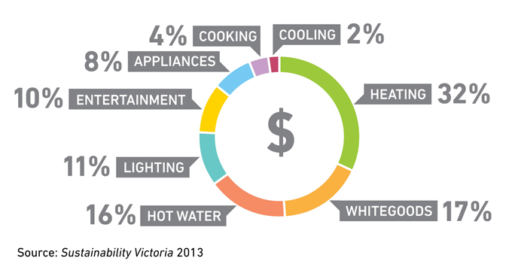

NatHERS is primarily used as the standard metric for new home building standards for building fabric, and an assessment requires detailed plans and material specifications.

Most existing homes have neither a NatHERS rating nor sufficient documentation readily available to conduct a NatHERS rating. The time required to document an existing house and discover all its materials’ properties to enable a NatHERS rating would therefore add a substantial cost to the assessment. This would become a barrier to the use of the Scorecard. A manual would have to be developed to guide consistent rating of existing homes under the NatHERS tool, as it was not designed for this purpose. A simplified method for calculating building fabric heating and cooling loads has therefore been developed to allow rapid and robust assessment.

Fixed appliances
The rating includes fixed appliances, based on the criteria in section 2.3.1. Additional detail on these elements is provided in later chapters.

The included energy uses are:
- heating,
- cooling
- hot water
- lighting
- pools and spas
- photovoltaic panels.
Heating, cooling and hot water data inputs make use of existing appliance star rating schemes for appliances covered by them. For appliances which are not covered by a star rating scheme, or where the star rating of an appliance cannot be easily determined, expert judgement estimates of efficiency are used, based on the age of the appliance and derived from MEPS/GEMS scheme data where available.

Lighting energy use calculations are based on a simplified assessment which identifies only halogen lighting. All other lighting is assumed to be provided at a level of 5 watts per metre squared, which is the current maximum set by the National Construction Code (NCC) for new homes.

Swimming pools use a significant amount of energy. Pools therefore add significant differentiation between houses, so pool use is included in the overall metric. Pools require substantial time to accurately estimate filter energy use as an assessor would need to measure the size of the pool, assess the wattage of the filter pumps and so on. Pools are not a common feature of Victorian homes (approx. 7 percent) so the Scorecard tool utilises a very simple assessment. The information required is limited to Yes/No answers for the type of chlorination and use of pool heating. The level of energy use reported is the average consumption.

Applying the key principles used to guide the development of the Scorecard (see section 2.3) excluded a number of energy uses. The following are not assessed by Scorecard.

Plug in appliances (such as TVs, computers, lamps, audio-visual devices, battery chargers)
- Energy use is very dependent on user behaviour and can be very difficult to model with any accuracy.
- These appliances can have very fast turnover, making assessments rapidly out of date.
- It can be hard to determine appliance efficiency from visual inspection.
- It is very difficult to demonstrate that the device is genuinely present/absent (devices are mobile so can be removed, hidden, or just very hard to find in an assessment).
- The appliance does not travel with the home, so affects only the household using it rather than the building stock.
- It is generally within the control of the householder to change, modify behaviour or upgrade performance of these appliances.
Cooking and dishwashers
- Stoves, ovens and dishwashers are fixed appliances but have low energy consumption.
- Upgrades to these appliances would not significantly change the overall rating.
Fridges, freezers and clothes driers
- These appliances are occasionally sold as part of the dwelling, but too infrequently to justify inclusion for all dwellings.
- It can be difficult to demonstrate presence/absence of these appliances as may be located in garage/un-plugged.
- Including these appliances could encourage gaming of the system by removing inefficient or installing more efficient appliances temporarily.
- It is generally within the control of the householder to upgrade the performance of these appliances, as the star rating is generally understood and used by consumers.
- These appliances have a faster turnover than the building fabric, making assessments out of date faster.

Renewable energy
Photovoltaic (PV) energy systems are in widespread use and provide significant differentiation between houses. The Scorecard uses techniques developed by the Office for Renewable Energy Regulation (ORER) to estimate energy generated. This reduces the need to collect data that is difficult to accurately ascertain by observation: area, type of panel, slope, orientation and overshadowing. This approach has some inbuilt conservative assumptions which cover a significant range of slope, orientations and overshadowing. The only input required is the rated generation capacity of the system in kW.

Inclusion of PVs is critical for the program. Over one million households have installed PV systems in Australia and their inclusion allows the benefits of these systems to be reflected in the overall rating of the house.

Renewable systems such as micro hydro or wind are not included, because:
- there is no significant domestic uptake at this point, and
- it is difficult to accurately model energy contribution without major investment of assessor time.

Other features
Some energy efficient features that are fixed in the home are not included in the assessment. These decisions have been taken because:
- the data collected would have minor impact on the total energy use of the home, and therefore the rating of the home,
- upgrade options have limited potential for improvement to the rating,
- the collection of data would be onerous, or
- it is difficult to model the impact of the feature.
The features listed below are all excluded from assessment because they meet one or more of the criteria above:
- Baths. The hot water energy required for a bath depends on the dimensions of the bath and the depth of fill. There is no data available on average depth of fill. Yarra Valley water studies (YVW, Yarra Valley Future Water, July 2011 p. 40) showed that around 80 percent of households do not use baths at all. Further, their studies show that bath water usage is a very small proportion of hot water use (YVW, 2011, p 43).

- Taps. Taps account for a small proportion of hot water use. While tap aerators provide a lower flow rate, they do not guarantee lower water use, because some tasks, such as filling a sink, are volume dependent. The length of pipe from the hot water system to the tap also influences the energy consumed, but collection of this data would unacceptably increase the time taken for the assessment. Due to the low impact of taps on hot water use, collecting data has been omitted. Within the algorithms a fixed allowance is made for the volume of hot water provided by taps depending on the number of occupants.

- Outdoor lighting. Lighting as a whole is a small proportion of total energy use and there is little data available on the use of outdoor lights as opposed to indoor lighting. Because of the uncertainty in modelling, the additional time taken to collect the data, and the minimal impact on the energy use of the house, data on outdoor lighting is not collected.

- Ceiling fans. Ceiling fans have a very small impact on the energy use of a house except where they provide the opportunity to avoid using a cooling appliance. The impact of ceiling fans on cooling energy use can be significant in northern humid climates. Integration of this effect has been deferred until northern climates are added to the Scorecard tool.

- Clotheslines. Clothes drying is only a small fraction (less than 1%) of total household energy use. While clotheslines provide the opportunity to avoid clothes-drying energy use, having a clothesline available does not guarantee its use; for example, in wet weather clothes lines do not provide a viable alternative unless they are covered, and may people use clothes driers because they are more convenient. The small impact and difficulty in determining the impact were the key reasons for excluding clothes lines from the assessment.

Star band development
The Scorecard communicates the overall performance of the home through a 10-star scale. Extensive research, analysis and testing has gone into the creation of this rating scale.

  - Figure 2: Scorecard star rating
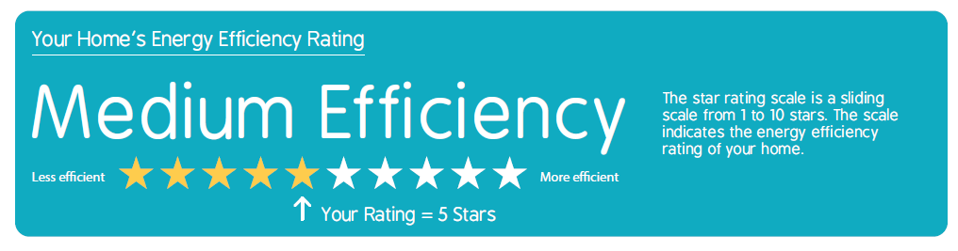

Market research and learning from international schemes
To support the key principles of the program it is important to develop a simple method to communicate the comparable energy performance of the home.

Results from international schemes and focus group testing of key scheme components provided critical learnings to drive the development of the star band metric. Householders strongly prefer a 10-point scale utilising stars as it is familiar and intuitive.

There is a strong consumer preference for the star metric to represent the total energy cost. Research found alternatives such as energy use per unit area are less preferred by householders and are often confusing.

Key messages from the research include:
- Energy prices and rising energy costs are the key concern of consumers. An energy cost metric helps householders select or upgrade to a house that will have lower bills and shows the extent of change needed to reduce their bills.
- It is important that the rating scale allows houses to move up the scale through undertaking energy efficiency improvements. This ensures that entire categories of home are not stuck at very low ratings.
- Some metrics are not well understood even where explanatory materials are provided.
- Some metrics are less intuitive or of less interest to consumers; for example, if a greenhouse metric was used, LPG and natural gas appliances would have the same impact on the rating even though LPG is three times more expensive than natural gas.
- Criticisms of other rating scales such as NatHERS have focused on the perceived lack of correlation between rating and energy costs.
Star ratings are also used for appliance energy performance, building standards, NABERS ratings, and other metrics indicating performance. It is considered critical that the Scorecard star bands be clearly explained, including how they differ from the NatHERS star ratings used in new home building standards. Despite the potential for confusion, consumers still preferred a star metric.

Use of total energy cost as the preferred star band metric
This policy analysis identified that establishment of star bands needed to consider consumer needs. Upgrades to higher stars should be achievable and intuitive, generating potential for material reductions in energy consumption.

Total cost was found to be a very effective basis for the star metric. It was broadly similar to using greenhouse gas emissions but provided a more intuitive result for consumers. If greenhouse emissions were used as the metric for star ratings, non-intuitive results would occur with fuels such as LPG or off-peak electricity. LPG has similar emissions to natural gas, however the cost is three times higher in Victoria. Houses with LPG space heaters would therefore receive the same ratings as houses with natural gas heaters but would have much higher energy bills. Furthermore, unless cost is used as the metric, day rate electric heating would rate identically to the same house with off peak electric heating, despite much higher electricity costs.

Energy cost
Since the tool fundamentally calculates energy use in different fuel types, a fuel tariff is required to convert calculated fuel energy to cost.

There is a plethora of energy cost tariffs with significant regional variation and changes to prices over time. Households also are in control of energy tariffs, and can switch providers, making tariff variation a ‘behavioural’ feature of home energy cost rather than a ‘fixed’ feature.

The cost of energy used for the calculation of the metric is based on a ‘cost index’ that reflects the average cost difference between the various fuels, rather than the actual cost of energy for the actual energy contract used by the current occupant. This means that costs only need to be updated when the relative costs of each fuel change significantly rather than following the rapid cycle of tariff changes. It is important to still provide consumers with information about how they can minimise the fuel tariffs as a complementary activity to the Scorecard e.g. Victorian Energy Compare website.

Development of star bands using a stock model of Victorian household fixed appliance energy use
Effective development of star bands and other characteristics of the Scorecard tool requires an estimate of the impacts of using a particular metric in the field. To facilitate this analysis a stock model of Victorian housing stock was developed.

The stock model considered a number of variations in building fabric and appliance ownership. Each individual case was weighted in terms of its market penetration; that is, the proportion of houses in the field which would be expected to have each particular building fabric specification, age, size and appliance ownership mix. To save analysis time, not every variation was modelled. The stock model only considers the most common variation but still covers 90 percent of the variation found in the field.

The project modelled:
- 50 variations in building fabric, representing dwellings of various size, age (which determines specifications like installation of ceiling insulation), and form including detached, semi-detached, flats and apartments.
- Six variations in heater type, with the area heated by space heaters limited according to likely appliance capacity.
- Six variations in air conditioner type, including ducted, split systems, evaporative and no cooling.
- Six variations in type of hot water system, including gas storage, instantaneous systems and off-peak electric both with and without solar boost.
- Three variations in the extent of use of halogen lighting including none, living areas only and whole house.
- Three variations in the installation of rooftop PV systems including none, 2kW and 4kW.
- Four variations in the type of pool including none, ordinary chlorination, salt water chlorination and gas heated.
This provides 388,800 variations in each of the six unique climate zones available in Victoria.

Development of star rating scale
Research into European Mandatory Disclosure schemes showed that two issues were key in developing effective ratings:
- Houses at the poor performance end need to be able to progress up the scale to higher ratings to provide incentive to improve.
- The top end of the scale should represent carbon neutrality or better.
With these findings in mind, the star scales were set using the following parameters:
- Three Scorecard stars represents average performance of the housing stock in Victoria.
- One Scorecard star represents the worst performing houses in the stock model.
- Nine stars represents a net zero energy cost for fixed assets under average house energy use behaviours.
- 10 stars represents a net negative energy cost; that is, generating more energy per year than is used.
- Six stars was set so that an average sized new house with an average suite of appliances in Victoria (3-star gas central heating and gas hot water system, 3-star space cooling with no halogen lighting and no PV) which obtained a NatHERS 6-star rating would achieve 6 stars on the Scorecard scale. The building fabric model was constructed using AccuRate, and the building fabric component rating generally reflects the ranking obtained using NatHERS tools.

Setting bands in this way gives a total distribution of ratings across Victorian building stock in the Melbourne Coastal climate as shown in Figure 3.

  - Figure 3: Scorecard star ratings for representative housing stock in the Melbourne coastal climate
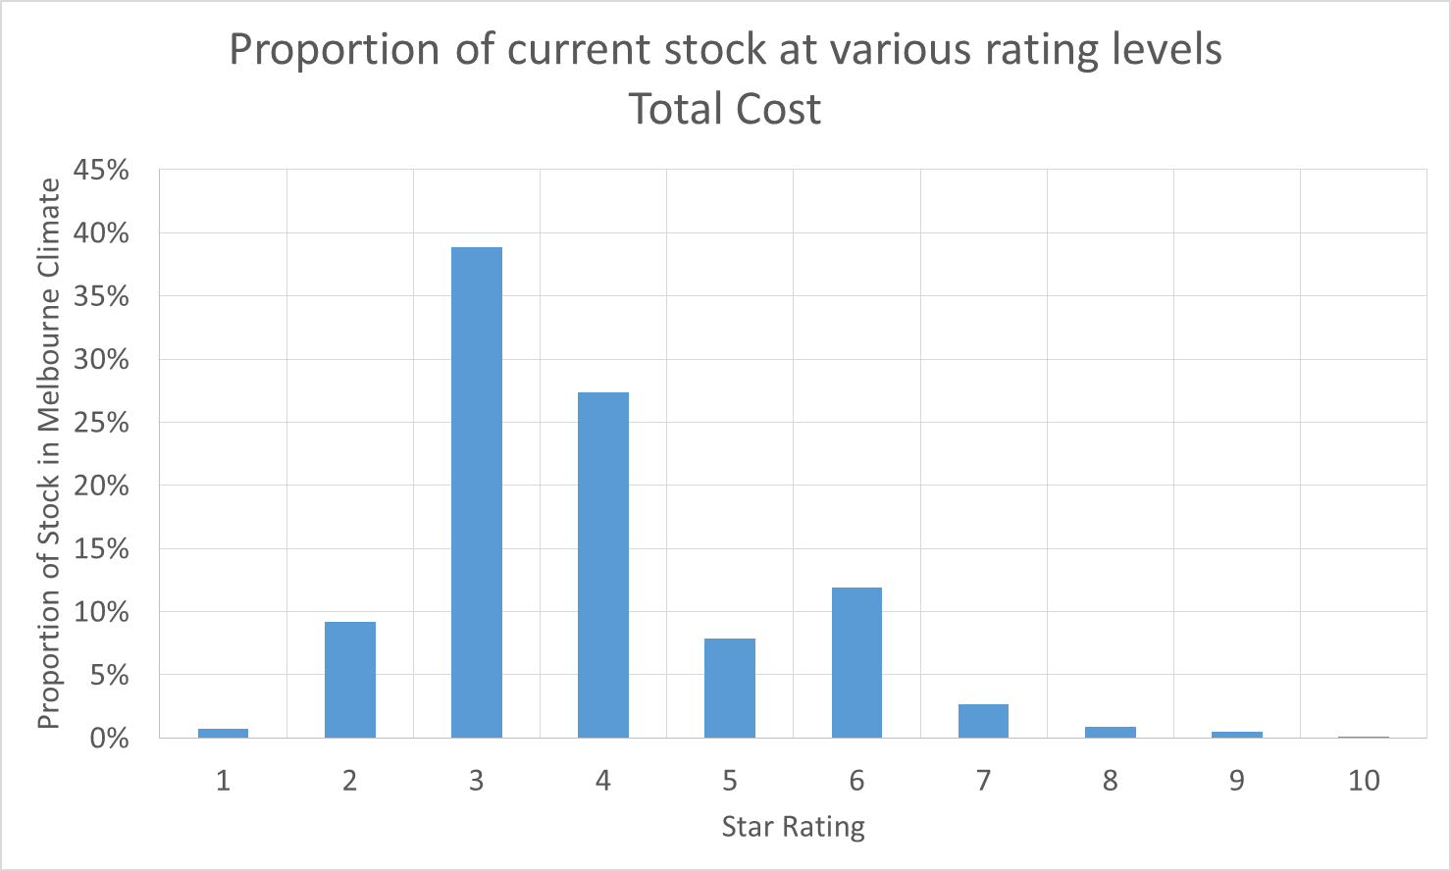
Distributions in other climates were similar. Most houses achieve a rating of three stars, and less than 10 percent of houses obtain ratings under three stars.

Impact of using a total cost metric on the ratings of large houses
The star rating metric is based on overall cost. On average, larger homes use more energy and therefore have higher energy bills. To ensure this did not have adverse policy consequences i.e that larger houses do not have high rating options available, an analysis was undertaken on the impact on larger homes.

To examine whether large houses would still be able to achieve high ratings, the largest house in the stock model (gross floor area: 320 m²) was examined to see what extent of upgrade would be possible when the house is centrally heated. The stock model showed that 95 percent of this house’s ratings under the variations tested were between 0 and 3 stars when central heating is used.

The house is assumed to include:
- Three-star gas ducted heating over 10 years old.
- Three-star gas storage water heating, 6.7 litre per minute showers.
- No halogen lighting (houses with halogen lighting could achieve the ratings below by upgrading to LED or similar low wattage lighting).
- No pool or PV system.
The house was assumed to be constructed to three different energy efficiency standards: pre insulation regulations, post insulation regulations and post 5 star regulation.

  - Table 1: Large house Scorecard star rating upgrade options
Age of construction and building fabric specification of house
Pre-insulation regulations: ceilings insulated | Post-insulation regulations:  ceilings and walls insulated | Post 5-star regulations:  NatHERS 5-star rating achieved
Current rating: 2 stars  To improve to 6 stars | Current rating: 2 stars  To improve to 8 stars | Current rating: 3 stars  To improve to 9 stars
Improvements required
Upgrade ceiling insulation to R3.0 | No insulation upgrade required | No insulation upgrade required
5-star gas HWS with solar | 5-star gas HWS with solar | 5-star gas HW with solar
4l/min showers | 4l/min showers | 4l/min showers
4 kW PV | 4 kW PV | 4 kW PV
Block all wall vents  Weather-strip all windows and doors  Use self-sealing exhaust fans | Weather-strip all windows and doors  Use self-sealing vent fans | No air leakage upgrades required
5-star ducted heating | 5-star ducted heating | 5-star ducted heating

Table 1 shows that large houses with central heating do have a viable upgrade path to higher Scorecard ratings.

Hot weather rating scale
The hot weather rating scale operates on a scale of one to five. A high rating means the home is easier to keep cool in summer. It should be noted that although data is collected on cooling devices, this rating does not consider the impact of cooling devices.

This is an important feature:
- It indicates how fast the house will heat up if there is a power failure or no cooling is installed.
- A poor rating may indicate that the home will be less comfortable, and potentially less safe or healthy, in a hot spell.
- The rating will have a level of correlation with ‘peak load’ of that home created by a cooling device.
The hot weather rating is based on the cooling energy load per square metre of house area, assuming all rooms except utility areas are cooled. This is a similar metric to the NatHERS calculated annual cooling load except that thermostat settings assumed are lower, in line with observed behaviour in the field as described in detail below. As a general rule, a house which requires more heat to be extracted by cooling appliances to maintain a comfortable temperature will get hotter without air conditioning than a house with lower cooling loads.

This metric has limitations. First, it is calculated for the house as a whole and so particularly poorly performing rooms are not identified. Second, the same cooling load does not always represent the same level of discomfort. A house which is very uncomfortable for a few hours may have the same cooling load as a house which is a little uncomfortable for many hours.

Calculation of hot weather discomfort can be evaluated with high-level accuracy through hourly building simulation tools such as NatHERS and detailed analysis of these results. Using NatHERS tools on existing homes in this way can be time consuming and costly. To allow existing homes to be assessed through a lower-cost option the approach of using cooling loads as a proxy for discomfort is the best current approach available. This is consistent with the BASIX approach of using energy loads as part of its thermal comfort criteria.

The hot weather rating scale runs from one to five. The upper end of the scale is relatively difficult to achieve as it implies that the house could maintain a level of comfort without air conditioning. This is a particularly challenging design task in all but the coolest climates in Australia. Further, in the absence of a more accurate methodology for defining discomfort it would be unwise to too easily award the top hot weather performance rating. Few houses are able to meet to top of the scale unless they have a NatHERS rating of at least 5 stars, internal thermal mass and excellent shading from summer sun i.e. utilise passive solar design principles.

Note that small houses struggle to achieve high hot weather ratings. This is because their surface area is greater and they have greater heat gains per square metre than larger houses. Smaller houses are harder to keep cool in reality and the tool reflects this.

The majority of existing stock receives only a one or two for its hot weather rating. This is because most housing stock does not perform well in summer. The dramatic rise in the sales of air conditioners in recent years is a symptom of this poor performance.

Further work is underway to refine the hot weather scale.

Home feature rating scales
Ratings are provided for building fabric, heating, cooling and hot water appliances, and lighting on a scale of 1 to 5 where a 5 star score indicates ‘best in class’. See Appendix A for an example certificate.

Ratings of heating, cooling and hot water appliances are based on the cost of the fuel used by the appliance divided by the efficiency of the appliance. It compares appliances based on the effective cost of each unit of energy supplied.

This allows the performance of appliances which use different fuels to be compared. Using this scale, you can compare the performance of a 5-star gas heater with a 5-star reverse cycle electric heater and an unrated wood heater. You can also see the impact of solar boosting on hot water system performance.

The lighting rating scale is based on installed wattage per square metre of floor area for halogen lighting. Rooms not lit with halogen lighting are assumed to be lit with a lighting density of 5 W/m² – the current maximum allowed by the NCC and easily achieved with compact fluorescent of LED lighting in existing houses. A house with little or no halogen lighting receives a 5/5 feature rating. Lighting is generally a low proportion of energy bills except where there is extensive use of halogen lighting. The intention of the scale is to provide an incentive to install energy efficient alternatives to halogen lighting.

The building fabric rating rates the performance of the whole home, whether or not a heating or cooling device is installed. It is calculated on the basis of the total heating and cooling loads (excluding appliance efficiency) per square metre of house area excluding utility rooms. This can be used to consider whether the home has, for example, major draught proofing issues throughout, which may affect comfort significantly but have less impact on the energy bill (and overall rating) if only the living area is heated and cooled.

This provides a generally consistent methodology for rating building fabric with the NatHERS system, but the area correction applied in NatHERS is not used. The Scorecard tool loads are calculated using a lower number of hours of potential use to reflect average occupancy in Australian houses, and using thermostats which better reflect what people actually use, such as lower cooling thermostats and the same heating thermostat in bedrooms and living rooms. The energy load thresholds are therefore not the same as those used for NatHERS.

The building fabric rating also focuses on differentiating the performance of existing stock in a 5 increment scale. Houses which achieve a 5-star NatHERS rating or better will generally achieve a 5/5 building fabric rating in the Scorecard and will receive no additional benefit for higher ratings. This is because the methodology used to calculate building fabric loads is a simplification of the load calculations in NatHERS and may not be accurate at higher rating levels. If a house has a rating above 5 NatHERS stars it is likely that a NatHERS rating has already been calculated, so home owners will already have a way of communicating the higher performance of their house. The rating scales are based on an analysis of outputs from the stock model showing the predicted frequency distribution of energy use in each unique climate zone.

Consistent approach to NatHERS ratings for building fabric
The Scorecard tool ties into the NatHERS rating in several ways:
- All climatic data has been developed from NatHERS weather files.
- The simplified building fabric model was developed to correlate with the predictions of Chenath.
- Building fabric component rating (5-increment scale) is based on the sum of heating and cooling loads in MJ/m² for all non-utility rooms whether these rooms have space conditioning appliances or not, similar to the NatHERS star rating. Note that the Scorecard assumes a different occupancy profile to allow valid comparison between energy end uses.
- The hot weather rating is based on the predicted cooling loads in MJ/m² for all non-utility rooms whether these rooms have space conditioning appliances or not, similar to NatHERS.
- Future functionality will include transfer of heating and cooling energy loads from NatHERS tools so that data entry is not repeated in the Scorecard. This may require that NatHERS tools have a Scorecard mode occupancy schedule.
- Rating star bands generally show a good relationship to NatHERS between 3 and 8 stars. See figure below with the gap between 1 and 3 stars extended to cover a broader range of existing house performance.

Figure 4 compares the shape of the NatHERS star bands with that of the Scorecard star bands for Melbourne. Loads are shown as a percentage of loads at 3 stars. Note that star band energy levels are show relative to the energy use at 3 stars. This shows the steeper slope of Scorecard star bands at lower performance levels.

  - Figure 4: Comparison with Scorecard star rating and NatHERS Star rating for the Melbourne climate zone

A 6-star rating in NatHERS will not guarantee a 6-star rating in the Scorecard if the house is large and appliances are inefficient. As explained above, the 6-star rating level has been set so that an average sized 6-star NatHERS rated house with the most common heating, cooling and hot water appliances at a 3-star efficiency level, no PVs and no halogen lighting will achieve around a 6-star Scorecard rating in Victoria.

The Scorecard generates broad correlation with NatHERS ratings. Nevertheless, clear communication to explain the differences between the various schemes has been developed and published to reduce confusion.

Development of the building fabric model

Need for a simplified building fabric model
The initial research for the Scorecard looked at all the available Australian tools which could calculate building fabric heating and cooling loads. These tools are effective at delivering to user needs but had significant limitations for use against the requirements of the project.

None of the tools deliver against the need of householders and have the right mix of speed of use, sufficient accuracy and the ability to calculate at average occupancy settings.

The analysis found that correlation against NatHERS was appropriate to improve consistency with the main approach used to evaluate building fabric in new homes.

How accurate do building fabric loads need to be?
As part of the work for establishing a simplified building fabric calculation technique, the level of accuracy required was examined. This looked at how variations in building fabric accuracy would affect the overall rating of a house.

In the example typical house, heating energy running cost was $735, cooling $79, hot water $375, lighting $279. The house is located in Melbourne and has efficient 5-star ducted heating, an efficient air-conditioner in the living area, a 3-star gas storage hot water system (HWS) and uses halogen lighting in the two main living areas. It has ceiling insulation but no wall insulation in the existing part of the house (two-thirds of the area) and a net area of 212 m². The house represents an average level of energy efficiency for Victorian stock, having an average area, the most common heating and cooling appliances etc. The house obtains a 3.5 Scorecard star rating.

Analysis of the impact of building fabric loads on the Scorecard rating shows that the heating and cooling can vary by up to 20 percent without changing the Scorecard star rating of the house. In terms of a NatHERS rating a 20 percent variation around one star in most climate zones. Because the Scorecard considers a greater range of energy uses than NatHERS e.g. hot water, lighting, heating and cooling appliance efficiency, the Scorecard rating is less sensitive to building fabric efficiency than NatHERS.

The table following shows the impact on the overall Scorecard rating of various levels of building fabric efficiency. It is taken from a stock model of Victorian housing, developed for this project (see section 3.5.4 and subsequent sections for a more detailed explanation).

The houses in the stock model were specified to match six typical specifications of building fabric efficiency.

  - Table 2: Building fabric specifications used in the stock model
Case | Description | Ceiling Insulation | Walls | Wall Insulation | Wall Height | Floor | Floor Ins | Wall vents | Chimneys | Window frame | Glass type | Approx NatHERS rating | Scorecard rating*
1 | Pre-‘60s+no insulation | R0.0 | Weather-board | R0.0 | 3.0 | Timber | 0 | 2 per main room | In main living | Timber | Single | 0.0 | 2.1
2 | ‘60s to ‘90s+no insulation | R0.0 | Brick veneer | R0.0 | 2.4 | Slab | 0 | 2 per main room | None | Alum | Single | 0.5 | 2.4
3 | Pre-‘60s+ceiling | R1.5 | Weather-board | R0.0 | 3.0 | Timber | 0 | 2 per main room | In main living | Timber | Single | 1.0 | 2.8
4 | ‘60s to ‘90s+ceiling | R 1.5 | Brick veneer | R0.0 | 2.4 | Slab | 0 | 2 per main room | None | Alum | Single | 2.0 | 3.9
5 | ‘60s to ‘90s+ceiling and wall | R 1.5 | Brick veneer | Foil | 2.4 | Slab | 0 | 2 per main room | None | Alum | Single | 2.5 | 4.1
6 | 1990s+ceiling and wall | R2.0 | Brick veneer | R1.5 | 2.4 | Slab | 0 | None | None | Alum | Single | 3.0 | 4.5
7 | Post 5-star+ceiling and wall | R3.0 | Brick veneer | R2.0 | 2.7 | Slab | 0 | None | None | Alum | Double low e | 5.5 | 5.2
* Note decimalised star are shown for the Scorecard for the purposes of this analysis but the Scorecard itself uses whole stars only.
The table above shows the relationship between NatHERS stars and Scorecard stars:
- A variation of over 5 NatHERS stars (0 stars from Case 1 to 5.5 stars in ins Case 7) produces only a 3-star variation in Scorecard. In other words, Scorecard gives about half a star change for each 1-star change in NatHERS rating.
- Going from post-insulation regulations (Case 6) at 3.0 NatHERS stars to post 5-star (Case 7) (5.5 NatHERS stars) is a 2.5 NatHERS star difference but only a 0.7 (5.2 – 4.5) star difference in Scorecard. This is only about one-third of the change to Scorecard stars for each NatHERS star.

This analysis demonstrates that, since the sensitivity of Scorecard to the performance of the building shell is relatively low, the accuracy of the estimation of heating and cooling loads for the Scorecard need only be within one star of the loads predicted by NatHERS tools to provide acceptable outcomes.

Scorecard building fabric model
The building fabric model is based on the Australian Greenhouse Calculator (AGC) model. It is a steady state heat flow calculation that uses weighting factors for each heat flow path (walls, floors, roofs, air leakage, conducted heat flow through windows and radiation heat flow through windows) to achieve a reasonable correlation with the heating and cooling loads predicted by the NatHERS engine (Chenath). For example, a weighting factor is used to reduce heat flows through walls for walls with high levels of thermal mass. These weighting factors were significantly revised from the original values in the AGC for the Scorecard tool in Victorian climates to improve the correlation with Chenath simulation predictions.

The improved correlation with Chenath was achieved by running 20 variations in building fabric in three house formats, creating a total of 60 house construction options to test. The three houses were selected and specified to match the average building specifications of pre-regulatory housing in Victoria because these houses represent the most significant volume of housing stock. Multivariate regression analysis was used to calculate weighting factors for each heat flow path and for individual construction elements with significant thermal mass.

The figure below shows the extent of correlation achieved for the three houses. The correlation achieved for the three houses is excellent and is much better than the +/- 1 NatHERS star which the Scorecard tool aims to provide. This is appropriate as the building fabric load estimates for houses which have significant design and specification departures from the three houses will not be as closely correlated.

  - Figure 5: Correlation of Scorecard building fabric load predictions with AccuRate predictions
CLIMATE ZONE | HEATING | COOLING
21 Melbourne  Used for inner city & surrounds | 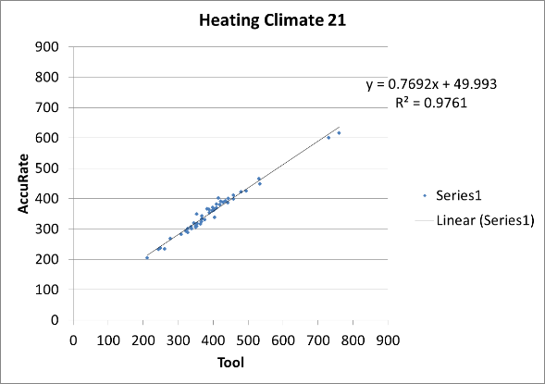 | 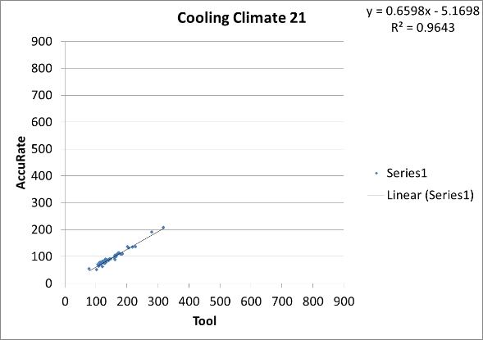
24 Canberra  used for Warrnam-bool and similar climates | 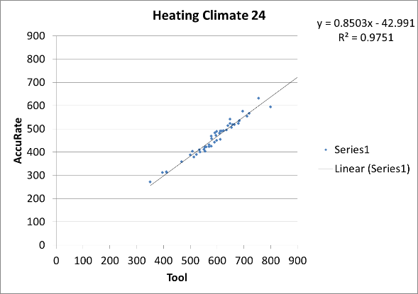 | 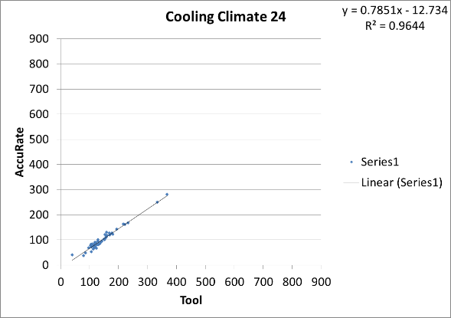
27 Mildura | 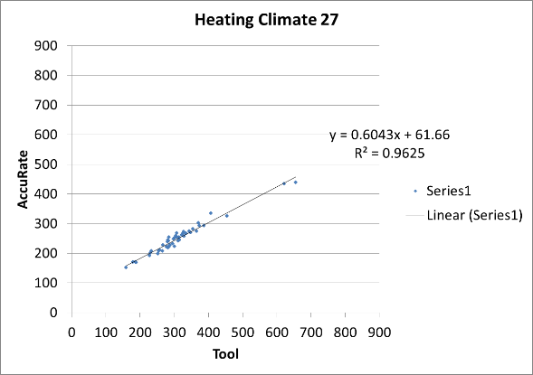 | 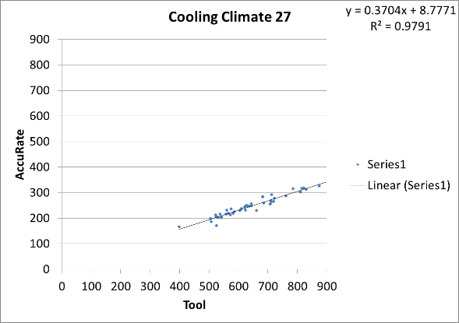
60 Tullamarine | 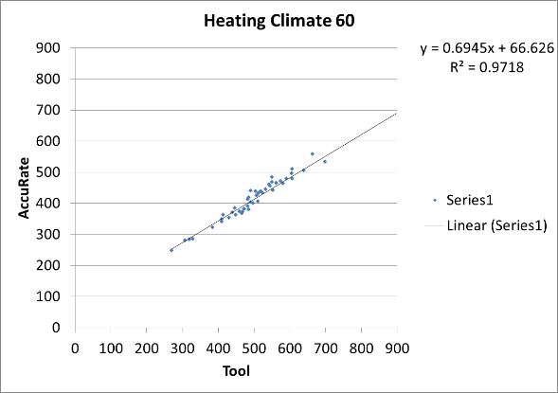 | 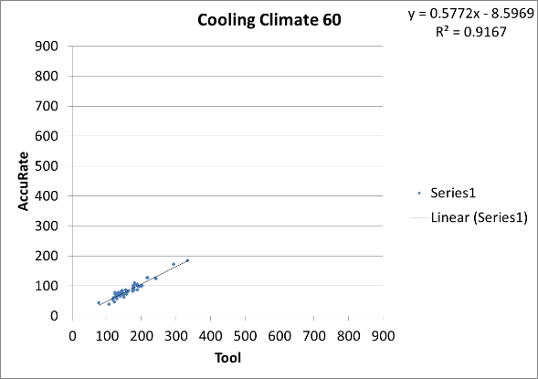
62 Moorabbin | 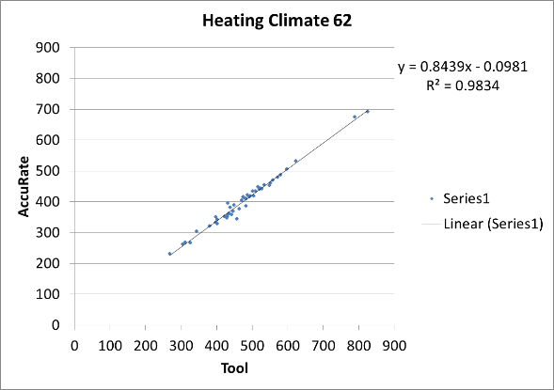 | 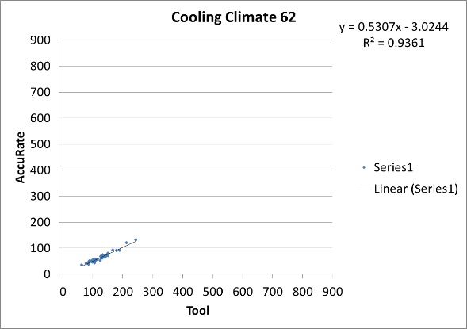
65 Orange – used for Ballarat | 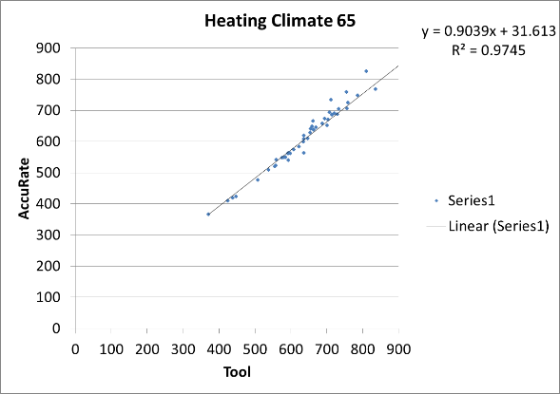 | 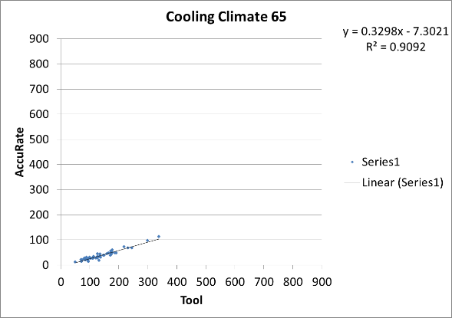

Climatic influences
Heat flows are driven by the difference in temperature between outside and inside, wind speed around the building and the amount of solar radiation. All measures of climatic specific drivers to heat flow through building fabric were developed from NatHERS climate zone data.
The Scorecard tool building fabric algorithms mirror the calculation of temperature differences for each heat flow path used in NatHERS.

- The measure of the climatic driver to heat flow through walls and ceiling/roofs was obtained by calculating the average sol-air temperature on medium-coloured walls and roofs in each climate when cooling is required and again when heating is required. This technique is based on the Heating Number and Cooling Number concepts that were used in Australian Standard 2627 ‘Thermal insulation of roof/ceilings and walls in dwellings’.
- The temperature under slab floors was derived from NatHERS simulation outputs which show the temperature of the ground under a slab. Temperatures in enclosed subfloors were found to approximate the average of the air temperature and the ground temperature.
- Temperatures under unenclosed floors are assumed to be the external air temperature, and this is also used for window conduction and air leakage.
- Heat flows through building fabric which is shared with adjacent units will always be small because Chenath assumes the temperature either side is assumed to be the same. This was approximated in the tool by applying high insulation R values (R50) to all shared elements.
- Impacts of solar gain through glass were calculated by determining the total solar radiation (per m²) falling on windows facing in the four cardinal orientations when heating is required, and separately for those hours when cooling is required. These total gain values were weighted using correlation with Chenath load predictions to better reflect the balance between heat gains and losses through windows on each orientation.
Calculation of heat flows also depends on the internal temperature that is assumed to be required by households, and when those conditions will be required (for example when the home is occupied).

The occupancy settings assumed for Scorecard are described in full in section 5 ‘User Assumptions’. The calculation of the climatic drivers for heat flow for the Scorecard were calculated for those hours where heating and cooling are typically required.

To determine these hours, 2.5 NatHERS star versions (the average NatHERS rating for existing building stock) of each house were developed and run in AccuRate in each climate zone. Those hours of the day where space conditioning was required were noted and the climatic drivers were only calculated for these hours. This approach is in contrast to other measures of climatic drivers, such as heating degree hours, which calculate for all hours of the day regardless of whether heating or cooling is typically applied during these hours. This approach therefore provides a more accurate measure of the climatic drivers to heat flow than those approaches which include all hours.

While most houses are occupied at night it was assumed that no heating and cooling would be required overnight because:
- In winter bedding provides adequate comfort.
- In summer temperatures at night are cooler and if cooling is used loads are much lower than during the day as shown by building fabric load profiles from AccuRate.
- While there is little statistical data available on heating and cooling overnight, anecdotally there is little evidence of this occurring except for some cooling in bedrooms when the cooling loads are much lower.
Cooling thermostats used for NatHERS are based on an approach called ‘free running adaptive comfort’. These temperatures are significantly higher than the air conditioned adaptive comfort temperatures that people will actually use when air conditioning. Thermostats used for the Scorecard reflect conditioned adaptive comfort. These thermostats are typically used for Regulatory Impact Statements for building fabric regulations and to predict future heating and cooling energy use in stock models of Australian housing. Energy Use in the Australian Residential Sector 1986-2020 explains the rationale for this in more detail. This report describes a stock model of Australian houses which was used to predict future energy demand from residential construction for the Australian Government. The outputs of the model were compared to actual energy demand and found to compare well to actual changes in residential energy consumption over time.

The Scorecard tool uses lower thermostat settings than are currently used in NatHERS tools in line with the findings of Energy Use in the Australian Residential Sector. In general, northern climates use 24 degrees; 23.5 is used from Brisbane to Sydney, and 23 is used for the rest except for some hot inland climates like Alice Springs.

Heating thermostats used in NatHERS are set to lower temperatures in bedrooms than in living areas. Bedrooms are also assumed to be heated to 15 degrees overnight. While there is a ‘common sense’ rationale for using lower temperatures in bedrooms, there is no evidence that bedrooms are heated to lower temperatures or that they are heated overnight. A single thermostat of 20 degrees used in Energy Use in the Australian Residential Sector regardless of the type of the room and no overnight heating is assumed.

  - Table 3: Climate settings
Climate type | Heating thermostat | Cooling thermostat
Hot  e.g. Darwin, Cairns, Alice Springs | 20 deg | 24 deg
Mild  e.g. Brisbane, Sydney, Perth | 20 deg | 23.5 deg
Cool  e.g. Hobart, Canberra, Melbourne, Adelaide, Albury | 20 deg | 23 deg

Aggregation of climates
The NatHERS scheme divides the Australian climate into 69 different climate zones (Chenath version 3.13). To reduce development effort while still maintaining sufficient accuracy in the estimation of building fabric cooling and heating loads, it was found that the number of climate zones could be significantly reduced by allocating each of the 69 climates to a representative heating and cooling climate. This approach is based on the findings of Energy Use in the Australian Residential Sector. The magnitude of heating and cooling energy use in each of the 69 NatHERS climates was examined and allocated to one of ten heating and ten cooling climates rather than simulate energy use in each of the 69 climates.

This process was slightly modified for Scorecard to improve the accuracy of the estimation of heating and cooling loads. In the Energy Use in the Australian Residential Sector study, inaccuracies in lower population areas did not affect the the accuracy of the stock model. For Scorecard, however, this accuracy is more critical so the number of heating and cooling climates was increased to 12.

In general, the allocation of climates means that capital cities – which have the highest numbers of houses – end up using their own climate zones. Typical allocations of heating and cooling climates for regional areas are shown in the table below.

  - Table 4: Typical allocations of heating and cooling climates for regional areas
NatHERS Climate Zone number | NatHERS Climate Zone name | NatHERS Heating Climate used in Scorecard (NatHERS Climate Zone number) | NatHERS Cooling Climate used in Scorecard  (NatHERS Climate Zone number)
9 | Amberley | Sydney East (17) | Moree (8)
20 | Wagga | Melbourne (21) | Brisbane (10)
23 | Launceston | Canberra (24) | Orange (65)
35 | Mackay | Townsville (5) | Moree (8)
52 | Swanbourne | Sydney East (17) | Tullamarine (60)
54 | Mandurah | Mascot (56) | Brisbane (10)
63 | Warrnambool | Canberra (24) | Moorabbin (62)
6 | Alice Springs | Mascot (56) | Townsville (5)
15 | Williamtown | Adelaide (16) | Brisbane (10)

Allocation of heating and cooling climates used is Scorecard for all the 69 NatHERS climates is shown in Appendix B.

Air leakage
Calculation of air leakage is particularly important for existing homes as draughts can significantly impact on the performance of the building fabric. The Scorecard tool establishes a new model for air leakage to consider the higher air leakage found in existing homes. While still based on the approach used in Chenath it is modified to reflect the higher air leakage rates found in existing homes and adds a number of air leakage sources not found in Chenath such as gaps in timber floors and leakage through evaporative cooling systems.

The correlations shown in this report between Chenath-predicted heating and cooling loads and Scorecard-predicted loads deliberately constrained the Scorecard to use the air change rate predicted by Chenath to keep the comparisons valid. The air change rates the Scorecard uses to calculate infiltration heating and cooling heat flows are based on air change rates derived leakage tests of existing houses.
A variety of data sources was used, including:
- The tracer gas measurement of air leakage that the Chenath air leakage model was initially derived from.
- CSIRO research (from the 1980s) which attributed air leakage to various air leakage sites in a house.
- A set of 45 blower door tests conducted by Sustainability Victoria (SV) of houses which were also rated using the FirstRate NatHERS tool.
The basic model for air leakage used in the Scorecard was adapted from the American Society of Heating, Refrigerating and Air-Conditioning Engineers (ASHRAE) Handbook of Fundamentals. This model assigns an equivalent leakage area to various air leakage sites, calculates wind driven and stack infiltration separately, and uses the air leakage properties of a house which are defined by blower door testing. The model makes an estimate of constants defined by blower door testing where a test is not available. These constants and equivalent leakage areas were updated to be consistent with the blower door tests provided by SV. The use of this approach facilitates the input of blower door test results at a later stage of the Scorecard tool development.

Figure 6 shows a comparison between the predicted natural air change rate using the model developed for the Scorecard and the natural air change rate predicted by the ASHRAE technique derived from the blower door tests conducted by SV.

  - Figure 6: Comparison of air change rates for the Scorecard and blower door predicted natural air change rates
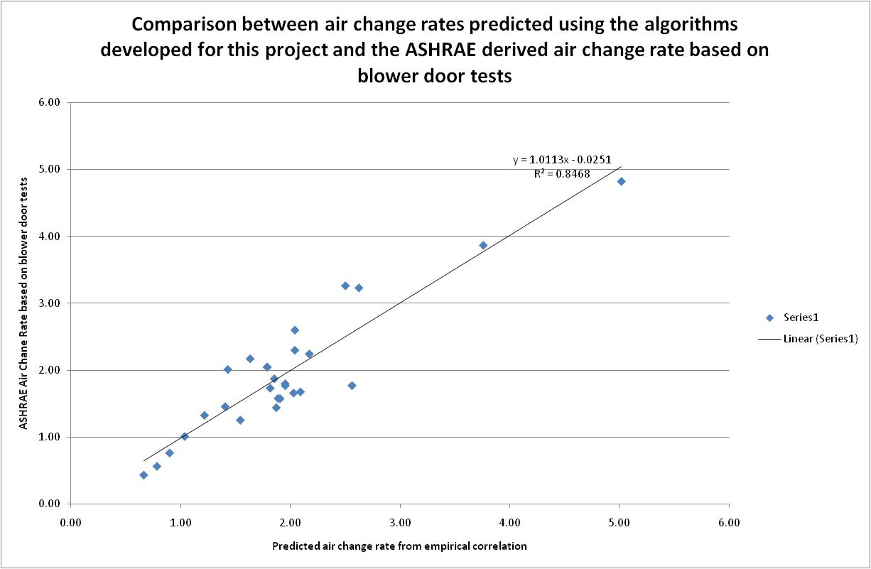

The Scorecard model predicts the air leakage rates in the blower door-tested houses within 0.5 air changes per hour in 81 percent of the houses.

The equivalent leakage areas (ELA) for various air leakage sites were derived through regression analysis which correlated the air leakage sites in each house with the natural ventilation rates predicted using the blower door tests. Note that the ELA of flues and chimneys was derived from earlier tracer gas testing because the blower door test cannot simulate the venturi effect, which drives air leakage for these features.

User assumptions
Many different families, with widely varying energy use needs, will live in a home over its lifespan. To allow a fair comparison between houses, average use conditions have been defined as shown in the sections below.

Heating and cooling
The use of the NatHERS occupancy assumptions would facilitate easier integration between NatHERS tools and the Scorecard. However, NatHERS occupancy provides a test condition that values the efficiency of the building envelope in all parts of the house that could be heated and cooled (all rooms except utility areas like bathrooms and laundries) at all times of the day and night (up to 17 hours per day when internal conditions are uncomfortable). This is a valid assumption for a scheme covering building fabric efficiency, but will not produce acceptable estimates of average heating and cooling loads in the field.

The Scorecard tool seeks to develop a measure of the average energy use of the fixed appliances in a house to provide a measure of the energy efficiency of the house. Because the NatHERS user behaviour pattern is not ‘average’ – and makes heating and cooling available for 17 hours a day rather than the average 11 observed from ABS household occupancy – use of the NatHERS pattern would potentially lead to heating and cooling inappropriately dominating the rating. If heating and cooling dominates the rating then important improvements to hot water, lighting and swimming pools may be overlooked when they could make a bigger difference to the energy efficiency of the home than the building fabric improvements.

The information below describes how the average occupancy settings for the calculation of heating and cooling building fabric loads were determined.

Thermostats
The assumptions about thermostats used by Energy Use in the Australian Residential Sector were used for the Scorecard tool. This provides a degree of validation of the thermostats used, which are:
- heating: 20°C in all spaces where heaters are installed, except for radiant heating defined below.
- radiant heating with thermostatic control: 18°C in all spaces where heaters are installed (doesn’t include wood fired appliances, but does include gas hydronic wall panels and slab heating).
- cooling: Cooling thermostats vary from 23 to 24°C depending on the location: warmer climates have higher thermostats. Note that market surveys in Darwin showed that 24°C was the average thermostat.

Hours of use
There is very little data available on hours of use of heating and cooling. This information was collected once by the ABS in National Energy Survey: Weekly Reticulated Energy and Appliance Usage Patterns by Season, Households, Australia, 1985-86 Catalogue No. 8210.0.

Appliance ownership and use has changed so much since this data was collected it is now of little use. ABS 4602.0.55.001 Environmental Issues: Energy Use and Conservation, Mar 2008 collected months of use of heating and cooling but provides little useful data in terms of hours of use.

The best data available was found in Energy Use in The Australian Residential Sector 1986 – 2020, published by the Federal Government in 2008. This analysed data collected on Household Occupancy in an ABS survey titled How Australians use their time (Time Use Survey) ABS4153. This study was undertaken by the ABS to obtain information about the way people allocate time to different activities. It was conducted in both 1992 and 1997 over four periods during each year to balance seasonal influences which might affect occupancy patterns. This gives an hourly dwelling occupancy percentage for each hour of the day and each day of the week.

  - Figure 7: Occupancy percentages
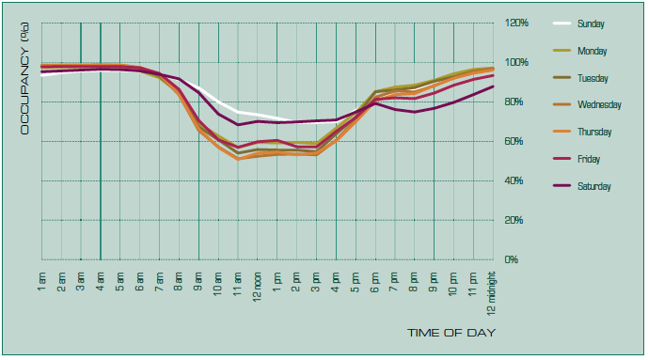

This analysis found that on average Australian homes are occupied for around 17.9 hours per day. There is little evidence of overnight heating or cooling (in Victoria). Excluding sleeping hours of midnight to 7 am gives an average occupancy for heating and cooling of 10.9 hours. This does not mean that houses are heated and cooled continuously for 10.9 hours a day; rather, that if conditions inside are uncomfortable during these hours, heating and cooling will be used.

Energy use for heating and cooling during daylight hours is significantly different to energy use outside these times because of the influence of the sun and the warmer temperatures during the day. The tool assumes that the house is occupied, and heating or cooling is available for use for 4.9 hours between 9 am and 5 pm (daylight hours) and for 6 hours outside these hours.

The stock model developed for Energy Use in the Australian Residential Sector 1986-2020 was shown to successfully predict the change in energy demand from utility residential energy consumption data, so the settings it recommends are robust. The average occupancy setting found in this study is typically used in regulatory impact statements for predicting the energy saved by building fabric regulations.

Hot water
All information on the use of hot water was taken from Yarra Valley Water studies, (YVW, 2011 Yarra Valley Future Water, Appliance Stock and Usage Patterns Survey published by Yarra Valley Water in Melbourne).

Cold water supply temperature to the hot water system is assumed to be the average air temperature for the climate zone based on analysis of NatHERS hourly weather data files.

Occupancy
The number of people in the house is a key determinant of hot water use. The number of occupants affects hot water use for dishwashing, clothes washing bathing and occasional use by taps.

A continuous function is used to allocate the number of people in the house given the area of the house. This was judged to be a better approach than simply using the number of bedrooms because:
- There is no way to objectively and repeatable define a bedroom (for example the number of bedrooms can be gamed by calling a bedroom a study).
- A large three-bedroom house has a greater capacity to accommodate more people and may therefore have a higher average occupancy than a small three-bedroom house over its life.
The number of people assumed to occupy a house is shown in the figure below.

Figure 9: Occupancy assumptions

The function above is derived using ABS average occupancy by number of bedrooms and assigning a minimum area for associated with one to four bedrooms (orange dots) as shown in the table below.

  - Table 5: Area and average occupancy
Area | Minimum bedrooms | Average occupants (from ABS)
35.0 | 1 | 1.22
50.0 | 2 | 1.79
100.0 | 3 | 2.50
175.0 | 4 | 3.36

Houses over 500 m² are all assumed to have the same number of occupants, and no house is assumed to have less than one occupant.

Clothes washing
The calculations consider the amount of hot water used in washing clothes through the average load of this task on the hot water system.

The calculations do not calculate the energy used by the specific washing machine present in the home for the reasons explained above.

The proportion of clothes washing which use hot wash and the water temperatures used (YVW, 2011).

  - Table 6: Clothes washing temperature
Wash Temp description | % | Temp
Hot wash | 4% | 55.00
Warm wash | 38% | 42.50
Cold wash (ambient temp) | 59% | 14.28*
* In climate 21, adjusted for ambient temperatures in other locations using average air temperature for location from NatHERS climate files.

Clothes washers are assumed to require 114 litres per wash (6 kg load capacity)
The number of washes per week is a function of the number of people in the house.

The table below shows the number of washes for whole numbers of people, but the assumed average occupancy is defined broadly based on YVW 2011 Appliance Stock and Usage Patterns Survey.

  - Table 7: Clothes washing loads
Number of People | Number of clothes washing loads per week
1 | 2.23
2 | 3.60
3 | 4.75
4 | 5.80
5 | 6.77

Bathing
All occupants are assumed to use showers for bathing and user behaviour is assumed to be standardised for the purposes of comparative rating.

The water efficiency of showerheads is the only input by the user. Shower temperature is assumed to be 40ºC, each occupant is assumed to have six showers per week and the average shower length is assumed to be 6.7 minutes (YVW, 2011).

A calculation is made of the energy required to heat the volume of water going into the showers. To account for multiple bathrooms, the flow rate of each showerhead is simply averaged. Any other apportioning system would likely require further understanding of the usage of each bathroom and may also be open to gaming such as assuming all showers happen in the shower with the lowest flow rate.

Hot water heating energy for baths is not included. Yarra Valley water studies (YVW, Yarra Valley Future Water, July 2011 p. 40) showed that around 80 percent of households do not use baths at all. Further, their studies show that bath water usage is a very small proportion of hot water use (YVW, 2011, p 43). This is not dependent on the type of tap but is highly dependent on occupant behaviour (for example, how much water is used to fill the bath), or the householder demographic (baths are most often used for small children).

Other hot water use
Hot water is not only used for bathing and clothes washing. It is also used for washing dishes, hand washing and a variety of other occasional uses. To make an estimate of these other uses, and the total hot water load in the house, the following assumptions are made.

Hot water for sundry use is assumed to be proportional to the number of people in the house. Washing of dishes is assumed to be undertaken using a dishwasher (78 percent of households in YVW 2011). Because modern dishwashers heat their own water and are cold connected, no hot water use by dishwashers is assumed.

While the use of aerators on taps should be encouraged as a water (and therefore hot water) saving measure, data on the presence of tap aerators is not collected by the Scorecard because:
- Use of hot water for washing dishes in a sink is dependent only on the level to which the sink is filled and is therefore independent of the flow rate, and washing dishes is the largest single hot water use from taps.
- Some rinsing and cleaning tasks may not deliver the full benefit of the reduced flow as the tap may be turned on for longer.
- Use of hot water from taps for clothes washing is independent of the tap flow rate.
- Bathing is the largest individual hot water use and is independent of tap efficiency.
- Measuring the flow rate of all taps is time consuming and would add little differentiation between houses due to the small volume of hot water used by taps.

Lighting
Lighting is on average responsible for only 4 percent of energy use and 9 percent of energy costs and greenhouse gas emissions of a typical household.

A study into the impact of the Victorian 5-star regulations by Wilkenfeld (2007) and Energy Efficient Strategies (EES) (2006) found that, “The energy-related emissions of the average new dwelling are nearly six per cent higher than the average emissions of existing dwellings. The emissions from the end uses targeted by the 5 Star requirements – heating, cooling and water heating – are significantly lower than in existing dwellings, but these gains appear to be more than outweighed by growth in emissions from lighting, which is not targeted by 5 Star.”

This increase in lighting use was found to be driven by the use of large numbers of halogen downlights to replace smaller numbers of conventional lamps. Due to the direction of the light they emit, more down-lights than conventional hanging lamps are generally required to light an area.

EES’s evaluation of average energy and greenhouse gas emissions in Victoria also showed that lighting energy consumption can exceed 12 percent of energy costs because it uses peak rate electricity when a large number of light fittings are used for halogen downlights.
For these reasons, it is important to include lighting.

As the main factor contributing to high lighting energy use is the use of halogen down-lighting, there is little benefit in discovering and disclosing the number of fluorescent and compact fluorescent fittings and LED downlights in a dwelling.

Each light is assumed to be on 1.32 hours per day in summer and 2.2 hours per day in winter. This was the average observed in reports by George Wilkenfeld & Associates. Halogen lighting is assumed to consume 60 Watts per fitting (includes transformer).

Where the number of halogens in a room are inadequate to light the whole room, or where there are no halogens installed the tool assumes that LED or compact fluorescent lighting provides the remaining lighting requirements based on 5 Watts/m² lighting density. If halogens are installed at less than 1 per 2.5 m², additional efficient light is assumed to be used in the room.

Pools and spas
Swimming pools account for only 1 percent of energy use and cost on average across Victoria. However, in homes with a swimming pool the filtration pump is often the largest single user of electricity. Thermal pool heaters, pumps for solar heaters and salt chlorinators also use significant amounts of energy.

If a pool or a spa is present then the average energy use is assumed to be:
- filter: 1300 kWh
- heating: 63,000 MJ + 960 kWh for the pump
- salt chlorination: 263 kWh
spa filter & heating: 2300 kWh

Photo voltaic panels
The amount of useful energy from each kW installed is calculated using the ORER method (2011). This already has some conservative assumptions built in which should be adequate to cover less than ideal installation.

The amount of solar radiation available at each location is based on the four solar zones in Australia from the Australian Standard.

Export ratio
Because the main metric is cost, the export ratio is needed to calculate the net cost impact. Export ratios are taken from Ausgrid research.

  - Table 8: Ausgrid export ratios
PV unit size | Median annual net exports kWh | Median daily net exports kWh | Median annual export ratio
1.0kw | 393 | 1.1 | 32%
1.5kW | 616 | 1.7 | 35%
2.0kW | 1007 | 2.8 | 41%
3.0kW | 1703 | 4.7 | 49%
4.0kW | 2378 | 6.5 | 52%
5.0kW | 2921 | 8.0 | 50%

Note: for each category we have also included systems that are within +/-0.1kW to provide a larger sample.
Sourch: Ausgrid, IPART

A curve of best fit is developed based on the data above to allow the determination of an export value for an arbitrary system size. The reduction in energy bills is then estimated by calculating an average benefit per kWh of energy generated with a benefit equivalent to the cost of electricity for non-exported kWh and the benefit of exported kWh valued according to the assumed feed in tariff. The current Victorian feed-in tariff of 11.3 c/kWh is assumed.

Appliance algorithms
The algorithms for appliance efficiency were taken from those developed by Alan Pears in the Australian Greenhouse Calculator. Alan has been developing these algorithms for over 20 years. They are based on appliance star ratings where these are available and have been supplemented with field measurements and the latest international research. Earlier versions of these algorithms have been used in NABERS residential tools, BASIX and the Green Loans Calculator. Use of these algorithms therefore provides a measure of continuity with these other tools.

All appliance energy efficiency algorithms break down the energy needed for each task into three components:
- Task efficiency: this uses information from star ratings schemes where available.
- Standing losses and start-up loads, such as heat losses from a storage water tank or start up energy required in an instantaneous hot water systems.
- Distribution losses, such as from hot water pipes or ducting.
Local climatic influences are also taken into account. For example, the temperature of inlet cold water for hot water systems is adjusted to match the average water temperature for each NatHERS climate zone and losses from hot water storage tanks are based on air temperatures in these climate zones.

The following section provides further information about the calculation of energy demands for each appliance.

Space heating
The efficiency of a heater is derived from the star rating, where this is available, and age.

The efficiency (or Coefficient of Performance) for reverse cycle heaters has changed over the years, as has the efficiency that is represented by each star rating. For example, a 1-star reverse cycle space heater was assumed to have a CoP of 2.3 between 2000 and 2005 but from 2012 onwards it has a CoP of 3.22. This variation in the coefficient of performance implied by the star rating is taken into account by entering the age of the appliance.

For heaters that do not have a star rating system, the efficiency is determined based on the Minimum Energy Performance Standard for the appliance and how this has varied over time, engineering calculations of performance as shown in the Australian Institute of Refrigeration, Air conditioning and Heating (AIRAH) handbook, and other appliance technical information.

Some considerations include:
- The efficiency of slow combustion heaters has improved due to the application of new Australian Standards from before 1990 to today.
- Modifying slab heating efficiency to allow for heat losses to the ground.
- Heaters that are primarily radiant, like hydronic panels, can achieve comfortable conditions at a lower temperature. In this case the heater thermostat is assumed to be 18 instead of 20.

Radiant heaters e.g. hydronic heating, can achieve comfort at lower air temperatures than air heating systems because they have a warm radiant panel which heats the occupants directly. For radiant heaters which are thermostatically controlled a lower heating thermostat of 18 degrees is used. This means that the Scorecard predicts heating lower energy use for thermostatically controlled radiant heaters. The impact of the lower thermostat setting is shown in the table below. The load multipliers for radiant heaters in the base winter climate zones represent the load for the radiant heater compared to the load for an air heater e.g. in climate zone 60, the heating load for a radiant heater will be 65% of the load for an air heater.

  - Table 9: Space heating load multipliers
NatHERS Climate Zone | Load multipliers for radiant heaters with 18 degree thermostat | NatHERS Climate Zone | Load multipliers for radiant heaters with 18 degree thermostat
1 | 0.00 | 24 | 0.70
5 | 0.22 | 27 | 0.61
8 | 0.57 | 39 | 0.35
10 | 0.39 | 56 | 0.46
16 | 0.55 | 60 | 0.65
17 | 0.40 | 62 | 0.62
21 | 0.60

Heaters which distribute heat from a central appliance to various rooms using ducts or pipework are less efficient due to the heat lost during distribution. These losses depend on the prevailing standards for duct and pipe insulation at the time the heater was installed. Losses also depend on the length of ductwork or pipes, but this information is difficult to discover. An average length of ductwork and pipes is assumed based on expert judgement and examining typical system layouts.

There will be subtle differences between heat losses from pipes compared to heat losses through ductwork, but because it’s not possible to examine distribution systems these subtleties cannot be ascertained. It was therefore decided to use the same level of heat loss for these systems.

The table below shows the assumed distribution losses assumed for central systems depending on the age of the installation. 0.3 represents a heat loss of 30 percent. The base efficiency of each appliance is multiplied by (1 – the distribution losses) to determine the final efficiency of the system. Higher losses for older systems represent the lower standards for duct and pipe insulation at the time.

  - Table 10: Distribution losses
Year | Assumed Distribution Loss
pre-1990 | 0.5
1990 to 2000 | 0.5
2000 to 2010 | 0.3
2011 onward | 0.2

Distribution losses are based on minimum regulations or standard practice before regulations e.g. minimum requirements for central heater ducts were introduced in the early 2000s and standard practice before this was for very minimal insulation.

Space cooling
Most common air-conditioning systems, except evaporative systems, have a star rating.

Star ratings and age of appliance are both entered into the tool because the efficiency represented by each star has been upgraded over time. The energy efficiency implied by the star rating is used together with any duct losses. Duct losses are assumed to be the same as for heaters and depend on the age of the installation to reflect the prevailing standards of the time.

The efficiency of evaporative cooling is taken from Energy Use in the Australian Residential Sector p88: “Based on published data from a range of manufacturers, an ‘equivalent’ EER value [energy efficiency] was calculated. Equivalence in this sense relates to the relative energy consumption of these systems rather than the energy service which is delivered. An equivalent EER of 12 has been used as this is representative of central ducted models which make up the majority of these systems. A lower equivalent EER (of the order of five to eight) would apply to smaller systems.”

A lower figure of 10.5 was used by the Scorecard because:
- The higher figure of 12 only applies to the largest systems.
- Evaporative cooling does not provide an equivalent level of comfort to reverse cycle and the lower figure represents more extensive use to improve comfort levels.

Hot water
Star ratings for hot water systems (HWS) are calculated on the same basis as heaters and coolers: cost of fuel divided by the appliance efficiency.

The energy needed for hot water is broken up into operational energy and standing losses. Operational energy is determined by predicting the amount of hot water required by the house and applying the system efficiency. Standing losses are calculated based on losses from the tank, pilot lights and start up energy requirements and reflect current minimum energy performance standards (MEPS) requirements for maximum losses allowable.

The energy demand predictions change with climate zones because the standing losses and cold water inlet temperature are adjusted on the basis of the appropriate climate for the postcode.

Off-peak storage HWS are assumed to use a tank of at least 160 litres while peak systems tanks are assumed to be between 80 and 160 litres depending on household size. All gas and LPG storage systems are assumed to have the same size tank for the calculation of standby losses.
The number of people in a house will affect the amount of hot water required and hence the HWS energy demand.

Impact of solar hot water heating panels
Solar radiation levels are set to values based on the state and relate to solar radiation available in the capital city. The energy demand for hot water is reduced by the amount of energy collected and an overall task efficiency is calculated for each HWS. This task efficiency is then applied to both operational energy requirements and tank losses. The area of panels is assumed to be 4 square metres.

For both speed of assessment and OH&S reasons it was decided that assessors would not be required to get up on the roof and measure panel areas.
The calculation of the impact of solar panels is based on the Office of the Renewable Energy Regulator methodology (2011) for calculating the contribution of solar panels to hot water loads for the purposes of providing certificates.

PV systems
Each postcode is allocated to one of the four zones in Office of the Renewable Energy Regulator (2011). This provides an effective annual kWh output per installed kW.

Allowance for installation practices
Poor installation practice can significantly reduce the output of PV systems. Measuring orientation and slope of panels was found to be difficult, taking significant time, generating the risk of working at heights, without generating major value to the householder. Overshadowing was also considered and found to be very difficult to assess, with the need to consider sun path over a year and the deciduous nature of vegetation. The Scorecard tool therefore makes a conservative estimate of PV system outputs instead. Users enter the kW rating of their systems in a range rather than enter the kW output directly.

Non-calculated features
The Scorecard tool allows the selection of ‘Additional Items’. These items are features that are present in the home and are likely to improve the energy performance, but for various reasons are not incorporated into the rating calculation.

Reasons for not incorporating the elements are:

- Features that require complex description and thermal calculations required beyond the ability of a simplified tool such as the Scorecard
  - Trombe Wall
  - Phase-changing material

- Features who’s impact cannot be determined by inspection
  - Non-PV renewable energy system
  - Heat exchange ventilation system
  - Solar room heating
  - Battery storage
  - Shading plants

- Features that primarily impact direct occupant comfort rather than room temperature
  - Ceiling Fans

Bibliography

Reference | Full Description
ABS 4182, 1999 | Australian Bureau of Statistics 4182.0, AUSTRALIAN HOUSING  SURVEY: HOUSING CHARACTERISTICS, COSTS AND CONDITIONS, Canberra, 2000
ABS 4602.0, 2008, 2011 | Australian Bureau of Statistics 4602.0, ENVIRONMENTAL ISSUES: ENERGY USE AND CONSERVATION, Canberra, 2008, and 2011
DIICCSRTE, 2013 | Department of Industry, Innovation, Climate Change, Science, Research and Tertiary Education, Australian National Greenhouse Accounts, National Greenhouse Account factors July 2013
DCCEE 2008 | ENERGY USE IN THE AUSTRALIAN RESIDENTIAL SECTOR 1986 – 2020, Published by the Department of the Environment, Water, Heritage and the Arts
IPART | IPART, Solar Feed-in tariffs, Setting a fair and reasonable value for electricity generated by small-scale solar PV units in NSW, March 2012
Roy Morgan Research, 2008 | Roy Morgan research, 2007 Victorian Utility Consumer Survey, Department of Human Services, Melbourne, 2008
Wilkenfeld, 2008 | Victoria’s Greenhouse Gas Emissions 1990, 1995, 2000 and 2005: End-Use Allocation Of Emissions for the DSE Victoria, 2008
Wilkenfeld, 2010 unpublished | Wilkenfeld, G., Commonwealth Guide to Preparing Regulatory Impact Statements for the National Appliance and Equipment Energy Efficiency Program
Yarra Valley Water, 2012 | Yarra Valley Water, 2011 APPLIANCE STOCK AND  USAGE PATTERNS SURVEY, Prepared by PETER ROBERTS, JUNE 2012

Appendix A: Example Scorecard certificate
Front page
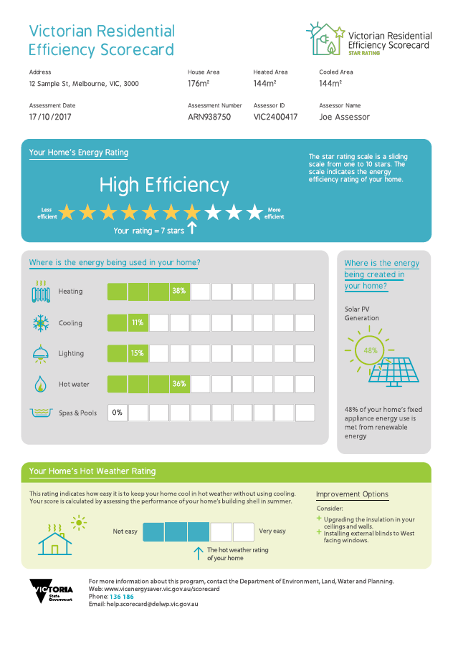

Back page
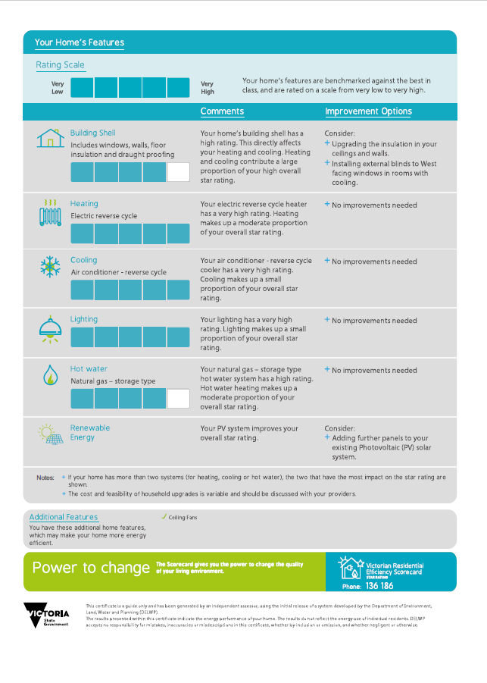

Appendix B: Climate zone allocation
  - Table 11: Designated heating and cooling climate zones
Summer Climate Zones |  | Winter Climate Zones
1 | Darwin | 1 | Darwin
5 | Townsville | 5 | Townsville
10 | Brisbane | 8 | Moree
16 | Adelaide | 10 | Brisbane
17 | Sydney RO | 16 | Adelaide
21 | Melbourne RO | 21 | Melbourne
24 | Canberra | 24 | Canberra
27 | Mildura | 39 | Mt Isa
56 | Mascot | 56 | Mascot
60 | Tullamarine | 60 | Tullamarine
62 | Moorabbin | 62 | Moorabbin
65 | Orange | 65 | Orange

  - Table 12: Allocation of designated climate zones
Original NatHERS Climate |  | New designation of climate zones
 |  | Heating Climate (Winter) |  | Cooling Climate (Summer)
1 | Darwin | 1 | Darwin | 1 | Darwin
2 | Port Hedland | 5 | Townsville | 39 | Mt Isa
3 | Longreach | 10 | Brisbane | 39 | Mt Isa
4 | Carnarvon | 10 | Brisbane | 16 | Adelaide
5 | Townsville | 5 | Townsville | 5 | Townsville
6 | Alice Springs | 56 | Moree | 5 | Townsville
7 | Rockhampton | 5 | Townsville | 39 | Mt Isa
8 | Moree | 56 | Mascot | 8 | Moree
9 | Amberley | 17 | Sydney East | 8 | Moree
10 | Brisbane | 10 | Brisbane | 10 | Brisbane
11 | Coffs Harbour | 17 | Sydney East | 21 | Melbourne
12 | Geraldton | 17 | Sydney East | 16 | Adelaide
13 | Perth | 56 | Mascot | 16 | Adelaide
14 | Armidale | 60 | Tullamarine | 60 | Tullamarine
15 | Williamtown | 16 | Adelaide | 10 | Brisbane
16 | Adelaide | 16 | Adelaide | 16 | Adelaide
17 | Sydney East | 17 | Sydney East | 17 | Sydney East
18 | Nowra | 16 | Adelaide | 21 | Melbourne
19 | Charleville | 56 | Mascot | 8 | Moree
20 | Wagga | 21 | Melbourne | 10 | Brisbane
21 | Melbourne | 21 | Melbourne | 21 | Melbourne
22 | East Sale | 60 | Tullamarine | 60 | Tullamarine
23 | Launceston | 24 | Canberra | 65 | Orange
24 | Canberra | 24 | Canberra | 24 | Canberra
25 | Cabramurra | 65 | Orange | 65 | Orange
26 | Hobart | 24 | Canberra | 65 | Orange
27 | Mildura | 27 | Mildura | 27 | Mildura
28 | Richmond | 16 | Adelaide | 16 | Adelaide
29 | Weipa | 1 | Darwin | 1 | Darwin
30 | Wyndham | 1 | Darwin | 1 | Darwin
31 | Willis Island | 1 | Darwin | 5 | Townsville
32 | Cairns | 5 | Townsville | 5 | Townsville
33 | Broome | 5 | Townsville | 1 | Darwin
34 | Learmouth | 5 | Townsville | 5 | Townsville
35 | Mackay | 5 | Townsville | 8 | Moree
36 | Gladstone | 5 | Townsville | 8 | Moree
37 | Halls Creek | 5 | Townsville | 1 | Darwin
38 | Tennant Creek | 5 | Townsville | 39 | Mt Isa
39 | Mt Isa | 39 | Mt Isa | 39 | Mt Isa
40 | Newman | 10 | Brisbane | 5 | Townsville
41 | Giles | 10 | Brisbane | 5 | Townsville
42 | Meekatharra | 10 | Brisbane | 8 | Moree
43 | Oodnadatta | 10 | Brisbane | 5 | Townsville
44 | Kalgoorlie | 56 | Mascot | 16 | Adelaide
45 | Woomera | 56 | Mascot | 8 | Moree
46 | Cobar | 16 | Adelaide | 8 | Moree
47 | Bickley | 27 | Mildura | 10 | Brisbane
48 | Dubbo | 27 | Mildura | 10 | Brisbane
49 | Katanning | 27 | Mildura | 16 | Adelaide
50 | Oakley | 56 | Mascot | 16 | Adelaide
51 | Forrest | 16 | Adelaide | 16 | Adelaide
52 | Swanbourne | 17 | Sydney East | 60 | Tullamarine
53 | Ceduna | 16 | Adelaide | 10 | Brisbane
54 | Mandurah | 56 | Mascot | 10 | Brisbane
55 | Esperance | 16 | Adelaide | 62 | Moorabbin
56 | Mascot | 56 | Mascot | 56 | Mascot
57 | Manjimup | 21 | Melbourne | 21 | Melbourne
58 | Albany | 21 | Melbourne | 65 | Orange
59 | Mt Lofty | 65 | Orange | 65 | Orange
60 | Tullamarine | 60 | Tullamarine | 60 | Tullamarine
61 | Mt Gambier | 60 | Tullamarine | 65 | Orange
62 | Moorabbin | 62 | Moorabbin | 62 | Moorabbin
63 | Warrnambool | 24 | Canberra | 62 | Moorabbin
64 | Cape Otway | 62 | Moorabbin | 65 | Orange
65 | Orange | 65 | Orange | 65 | Orange
66 | Ballarat | 65 | Orange | 60 | Tullamarine
67 | Low Head | 62 | Moorabbin | 65 | Orange
68 | Launceston Air | 65 | Orange | 65 | Orange
69 | Thredbo | 65 | Orange | 65 | Orange

See https://www.victorianenergysaver.vic.gov.au/residential-efficiency-scorecard
Frederiks et al 2015, Household Energy Use: Applying Behavioural Economics to Understand Consumer Decision Making.
ACEEE 2014, Lessons Learnt from the US Department of Energy’s Home Energy Score.
Low Carbon Living CRC 2016, Enhancing the Market for Energy Efficient Homes.
http://www.epa.vic.gov.au/AGC/home.html
Cabinet Office Behavioural Insights Team, 2011, Behaviour Change and Energy Use; Pers Soc Psychol Bull 2008, 34, Normative Social Influence is Underdetected; Rocky Mountain Institute and Building Performance Institute, 2016, A Promising Way for Service Providers to Unlock Investments in Home Energy Upgrades.
Improvements are calculated as the improvements most likely to increase the home’s star rating. The cost of the upgrade is not calculated as there are many home specific considerations that drive cost. The Scorecard assessor will discuss the options and likely costs with the householder, and the householder’s budget and needs.
Chenath is the name for the calculations that sit behind all NatHERS tools, see http://www.nathers.gov.au/newsletters/issue-3-december-2016/get-know%C2%A0chenath
Although the Scorecard rating are reported in whole numbers, for analysis purposes smaller increments are sometimes examined
http://www.nathers.gov.au/nathers-accredited-software/nathers-climate-zones-and-weather-files
Energy Efficiency Upgrade Potential of Existing Victorian Houses, SV, 2015
DCCEE 2008

