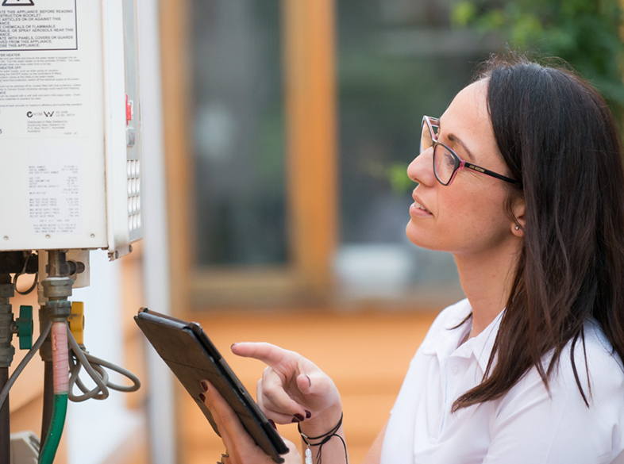
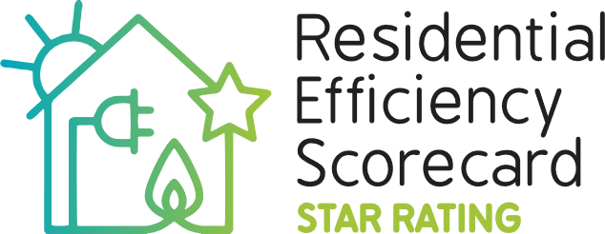

National Scorecard Initiative
  - 2025 Annual Report

We acknowledge and respect Australian Traditional Owners as the original custodians of Australia’s land and waters, their unique ability to care for Country and deep spiritual connection to it. We honour Elders past and present whose knowledge and wisdom has ensured the continuation of culture and traditional practices.

Acknowledgements

We would like to thank Residential Efficiency Scorecard Assessors around the country who have made the program what it is today. We also extend our thanks to colleagues in all jurisdictions and the Commonwealth.

The National Scorecard Initiative, which builds on the Victorian Government’s successful state-based Residential Efficiency Scorecard program, facilitates a nationally consistent approach for assessing existing homes. In 2019, Scorecard piloted nationally and was trialled further in 2021 with support from all governments.

This work is licensed under a Creative Commons Attribution 4.0 International licence. You are free to re-use the work under that licence, on the condition that you credit the State of Victoria as author. The licence does not apply to any images, photographs or branding, including the Victorian Coat of Arms, the Victorian Government logo and the Department of Energy, Environment and Climate Action (DEECA) logo.

To view a copy of this licence, visit http://creativecommons.org/licenses/by/4.0/

ISBN 978-1-76176-749-4
Author The Residential Efficiency Scorecard

This publication may be of assistance to you but the State of Victoria and its employees do not guarantee that the publication is without flaw of any kind or is wholly appropriate for your particular purposes and therefore disclaims all liability for any error, loss or other consequence which may arise from you relying on any information in this publication.

© Copyright State Government of Victoria, Department of Energy, Environment and Climate Action, 2025

Contact us
Please email your enquiry to scorecard@deeca.vic.gov.au
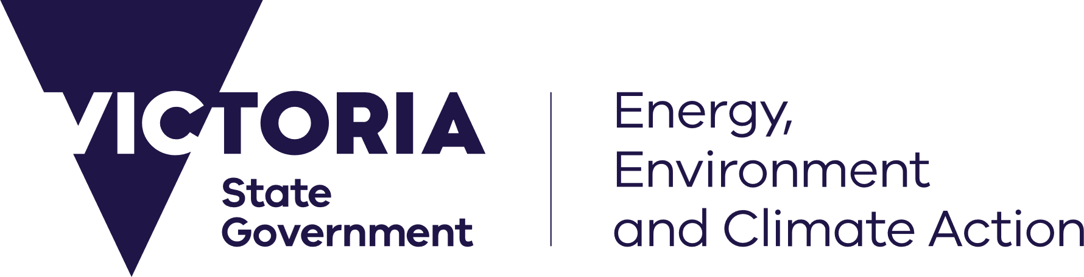
Contents
Acknowledgements 2
Abbreviations and common terms 5
Executive summary 7
Background 9
Introduction 10
Scorecard program delivery 10
Activity 1, Continue development and support the National Scorecard tool to enable it to be used nationwide in all Australian climates 10
Assessments 10
Assessors 11
Activity 2, Undertake accreditation work of the National Scorecard tool against the NatHERS benchmark tool for existing buildings 12
Activity 3, Provide tool technical updates, assessment quality checks, data analysis & reporting, technical explanatory products, and technical updates 12
Updates to the Scorecard tool 12
Quality assurance 12
Bulk data audit 13
Light audits 14
Quarterly desktop audits 14
Telephone survey 15
Activity 4, Maintain help desk, user support, training and accreditation of assessors for the National Scorecard 16
Assessor training 16
Trainee assessor pipeline 16
Trainee assessor satisfaction 17
Engaging with AAOs 17
Helpdesk 17
Activity 5, Provide overall management and administration of the National Scorecard 18
Communications and marketing 18
Program engagement 19
SECCCA pilot 22
Local government programs 22
Jurisdictional Advisory Group 23
Program Advisory Group 23
Appendix 1. NatHERS for existing homes 24
Appendix 2. 2024/25 assessment data insights 26

Abbreviations and common terms

Abbreviations
AAO - Assessor Accrediting Organisation
ACT - Australian Capital Territory
DCCEEW – Australian Government Department of Climate Change, Energy, the Environment and Water
DEECA – Department of Energy, Environment and Climate Action, Victoria
ECSA – Energy and Climate Change Special Account
ESOM - Energy Senior Officials Meeting
HERA – Home Energy Rating Assessment, a prescribed activity under the Victorian Energy Upgrades program providing discounted Scorecard assessments to Victorian households
JAG – Scorecard and NatHERS Jurisdictional Advisory Group
NatHERS - Nationwide House Energy Rating Scheme
NSW – New South Wales
NT – Northern Territory
OERC – Otago Energy Research Centre, University of Otago, New Zealand
PAG – Program Advisory Group
QLD – Queensland
RBC – Resilient Building Council
RTOs – Registered Training Organisations
SA - South Australia
SQAP –Scorecard Quality Assurance Panel
TAS - Tasmania
VEU – Victorian Energy Upgrades program
VIC - Victoria
WA - Western Australia
YESS - Your Energy Saving Solutions

Common terms
This year – the 2024/2025 Financial year
NatHERS Administrator - NatHERS is administered by the Australian Government Department of Climate Change, Energy, the Environment and Water on behalf of all states and territories.
NatHERS Scorecard Agreement - 2021-25 Commonwealth State Agreements ‘Nationwide House Energy Rating Scheme Residential Efficiency Scorecard Agreement
Scorecard – National Scorecard Initiative funded by ESOM
Scorecard program – Led by the Scorecard team who perform a combination of administrative functions, software and technical support, helpdesk, training and accreditation, and quality assurance
Scorecard team – Scorecard program staff
Scorecard tool – software designed to measure energy efficiency developed in Victoria. Launched in May 2017
Scorecard Funding Agreement – National Scorecard Initiative ECSA funding agreement 2024/25

Executive summary
The Scorecard program has now completed the fourth and final year of the National Scorecard Initiative. This year saw ongoing uptake, with Scorecard assessors completing a total of over 3,000 assessments, an increase of 36% on the previous financial year. There have now been more than 13,000 Scorecard assessment undertaken over the lifetime of the program.
Scorecard has continued its involvement in a range of projects and programs, including those with local government, as well as partnering with organisations to trial the delivery of combined resilience and energy efficiency ratings, and pilot a version of Scorecard suitable for application in New Zealand.
Throughout the year, the Scorecard team also engaged with the NatHERS Administrator through meetings and workshops designed to develop suitable NatHERS processes for existing homes.
The Scorecard Program received a total of $1,200,000 funding this year from the Energy and Climate Change Special Account (ECSA). This supported the continued delivery of 5 activities:
- Continue development and support the National Scorecard to enable it to be used nationwide in all Australian climates
  - Scorecard assessors completed 3,020 Scorecard assessments across Australia this year.
  - The number of accredited assessors grew from a baseline of 144 to 165 by June 2025.
- Undertake accreditation work of the National Scorecard tool against the NatHERS benchmark tool for existing buildings
  - Scorecard continued to engage with the NatHERS Administrator on a range of tool development and accreditation activities through meetings and workshops designed to develop suitable NatHERS processes for existing homes.
- Provide tool technical updates, assessment quality checks, data analysis & reporting, technical explanatory products, and technical updates
  - The key update to the Scorecard tool this year has been the addition of the companies model which allows companies to understand and perform quality assurance on assessments by sub-contractor and employee assessors.
  - The Scorecard team used a variety of audit techniques to perform routine assessment quality checks. This included a bulk audit, light audit and desktop audit. The bulk and light audits were used to identify which assessors would be subject to the more rigorous desktop audit. Scorecard audited 100% of assessments this year using the bulk data audit process.
- Maintain help desk, user support, training and accreditation of assessors for the National Scorecard
  - An external provider continued to deliver the Scorecard training program on behalf of DEECA. The training program includes 2 webinars and 12 self-paced modules. This year, 48 applicants completed both training webinars, and a total of 122 applicants were working through the Scorecard accreditation process.
  - Scorecard successfully partnered with two Assessor Accrediting Organisations (AAOs) to pilot the delivery of assessor accreditation. The pilot has been extended to 23 June 2026, when Scorecard will close.
  - The Scorecard team continued administration of 2 central helpdesks, with over 498 unique enquiries received through both helpdesks. Technical enquiries or questions about the Scorecard tool remained the predominant subject making up over 43% of enquiries.
- Provide overall management and administration of the National Scorecard
  - The Scorecard team adheres to a detailed Complaints Policy that clearly outlines the steps to be taken in the event a consumer complaint is received. The Scorecard program received one complaint this year.
  - The Scorecard team produced a range of communications and employs a variety of channels to keep stakeholders informed about program developments. These include:
    - email newsletters
    - the national Scorecard website
    - Scorecard social media channels
    - flyers, fact sheets and other marketing materials
  - The Scorecard team represented the program at various industry forums.
Energy and Climate Change Special Account (ECSA) funding
ECSA funding was fully expended against the delivery of these activities, with the expenditure acquitted in accordance with the requirements set out in the Funding Agreement.
This year funded projects included:
- Scorecard IT tool updates, technical support, and IT hosting
- National Scorecard Quality Advisory Panel
- Scorecard training and accreditation
- National website
- Auditing and householder phone survey
- Digital media campaign.

Background
The National Scorecard Initiative was agreed by the Energy Senior Officials Meeting (ESOM) in July 2021 and endorsed under the Nationwide House Energy Rating Scheme (NatHERS) in August 2021.
The production of an Annual Report for the 2024-25 financial year (this year) is a requirement of the multi-year 2021-25 ‘Nationwide House Energy Rating Scheme Residential Efficiency Scorecard Agreement’ (NatHERS Scorecard Agreement) and the ‘Scorecard ECSA funding agreement 2024-25’ (Scorecard Funding Agreement).
The NatHERS Scorecard Agreement sets out items that the program must report against annually. This document addresses those items and also contains information on activities that Scorecard is not required to report on but is included to locate the program within the broader context of improving the energy efficiency of existing homes across Australia.
The Victorian State Government, Department of Energy, Environment and Climate Action (DEECA), deliver the National Scorecard Initiative on behalf of all Australian governments.
The National Scorecard Initiative objectives for 2021-25 are to:
- Deliver the National Scorecard Initiative
- Maintain high levels of benefit, quality and trust in all jurisdictions
- Achieve Scorecard Tool accreditation under NatHERS for existing homes and work with the Australian Government to transition Scorecard training and accreditation to NatHERS for existing homes
- Build the national market for Scorecard
- Prepare systems and supports for mass uptake.
The program scope includes:
- Working with the Australian Government Department of Climate Change, Energy, the Environment and Water (DCCEEW) to support development and implementation of the NatHERS for existing homes framework.
- Delivery and further development of the Scorecard program across Australia from July 2021, providing the National Scorecard Tool, and related training, accreditation and communications.
- Working with jurisdictional and other partners on the Scorecard program to support uptake, jurisdictional priorities, policies and projects, and maximising community benefits of the Initiative.
- Administering the Scorecard program: providing a website, email, call centre, communications, Scorecard and Assessor Update e-newsletters, presentations, and responding to external requests.

Introduction
Scorecard has now completed the final year of the four-year National Scorecard Initiative. The 2025 Annual Report documents the delivery of activities required under the initiative and highlights the work of the program to provide an energy performance rating tool for use in existing homes that is national, reputable, robust, accurate and trusted.
This year saw the highest number of Scorecard assessments in the history of the program. Scorecard assessors completed over 3,000 assessments in the 2024-25 financial year, bringing the total number of assessments undertaken over the lifetime of the Scorecard program to over 13,000.
While the inclusion of Scorecard in the Victorian Energy Upgrades (VEU) program under the Home Energy Rating Assessment (HERA) activity has continued to drive a significant proportion of assessments, there has been healthy uptake in several other jurisdictions, most notably New South Wales and South Australia.
Scorecard worked with a range of organisations across sectors, including councils, not-for-profits, researchers and developers. A notable example was the work undertaken for the Building Research Association of New Zealand (BRANZ) and Fletcher Homes to develop a pilot version of Scorecard suitable for use in New Zealand.
In addition, the Scorecard team has continued to work with the NatHERS Administrator to assist in developing the framework for assessing existing homes.

Scorecard program delivery
Program funding of $1,200,000 received from the Energy and Climate Change Special Account and the Australian and Victorian governments is allocated to the delivery of 5 high-level multi-year activities. This section reports progress against each of these activities.

Activity 1, Continue development and support the National Scorecard tool to enable it to be used nationwide in all Australian climates

Assessments
This year, Scorecard assessors completed 3,020 assessments across Australia. This is a substantial increase from the previous financial year, with the total number of assessments increasing by 807 compared to last year. Around 81% of all assessments took place in Victoria, and 9% in New South Wales.

Number of assessments by financial year

Assessors
From 1 July 2024 to 30 June 2025, the number of accredited assessors grew from 144 to 165. Ninety-four of these accredited assessors are based in Victoria and 71 are based in other jurisdictions.
The Home Energy Rating Assessment activity under the Victorian Energy Upgrades program continues to drive uptake of assessments along with a continuing increase in the number of accredited assessors this year.
Financial Year | ACT | NSW | NT | QLD | SA | Tas | Vic | WA | Total
Total on 30 June 2021 | 0 | 5 | 1 | 3 | 7 | 2 | 54 | 4 | 76
Total on 30 June 2022 | 3 | 12 | 1 | 4 | 7 | 2 | 60 | 4 | 93
Total on 30 June 2023 | 7 | 23 | 1 | 5 | 12 | 4 | 62 | 5 | 119
Total on 30 June 2024 | 7 | 24 | 1 | 5 | 13 | 4 | 84 | 6 | 144
Total on 30 June 2025 | 7 | 29 | 2 | 7 | 15 | 4 | 94 | 7 | 165

Assessor numbers - June 2021 to June 2025

Activity 2, Undertake accreditation work of the National Scorecard tool against the NatHERS benchmark tool for existing buildings
The Scorecard team continued to engage with the NatHERS Administrator on a range of proposed tool requirements and accreditation proposals, including participating in the User Interface Protocol Technical Working Group. Feedback and comments on NatHERS for existing homes documents were also provided through membership of the NatHERS Technical Advisory Committee (TAC) and Stakeholder Consultative Group (SCG), as well as providing feedback through DEECA representation on the NatHERS Steering Committee (NSC).
Work also commenced on developing a conversion process to create AccuRate Enterprise (existing homes mode) input files from Scorecard assessment data files.

Activity 3, Provide tool technical updates, assessment quality checks, data analysis & reporting, technical explanatory products, and technical updates

Updates to the Scorecard tool
The main update to the Scorecard tool has been the addition of the Companies model which allows companies to understand and perform quality assurance on assessments by sub-contractor and employee assessors.
Since Scorecard accreditation is of individual assessors, and only they can see the assessments they create in the tool, it can be hard for companies to manage assessments that are done in their name.
To provide some visibility, a new approach was created where companies could be created in the Scorecard tool. Companies can invite assessors to associate with the company, and then assessors can assign assessments to associated companies.
Company users then have a read-only view of assessments assigned to the company.
This enables companies to check the progress of their assessments and perform quality assurance, for example checking evidence photos are correct.

Quality assurance
The Scorecard team manages the Scorecard quality assurance program with support from 4 Scorecard assessors who are part of the Scorecard Quality Assurance Panel (SQAP). The SQAP is comprised of the administration and technical staff on the Scorecard team as well as independent, experienced Scorecard assessors. SQAP assessors can reside in any jurisdiction and participate through online meetings and secure information sharing. SQAP members must declare they do not have a conflict of interest whenever assessing an applicant or an assessor’s work.
Scorecard quality principles
Scorecard assess applications, exams and audits against the Scorecard Quality Principles:
- Excellent customer experience. Assessors must demonstrate strong customer relationship and engagement approach and skills, delivering a positive experience for the consumer.
- Robust assessment approach. Assessors must have a strong ability to identify home energy efficiency features in the field and accurate data entry skills, to ensure assessments accurately reflect home performance.
- Consumer-focused energy efficiency upgrades advice. Assessors must have the skills to assess and present appropriate upgrades options, considering the needs of the household.
- Knowledge of safety and well-being. Assessors must have the skills to protect themselves and others while working.
- Robust administrative process. Assessors are given Scorecard training and other support services, and must comply with administrative requirements, including audits.
- Consultation and continuous improvement. Assessors are invited to provide feedback to continuously improve the scheme.

Bulk data audit
Scorecard uses bulk assessment data audits to understand outliers in the Scorecard data that might point to errors made by assessors. This bulk data audit serves 3 main functions:
- finding errors that an assessor is consistently making, thereby requiring follow-up communication
- finding assessors who are making a range of different errors, thereby requiring further auditing
- finding errors that multiple assessors are making, showing a need for clearer guidance documents.
Scorecard audited 100% of assessments this year using the bulk data audit process. The main adverse findings in the bulk data audit were:
- duplicate assessments, where an assessor has copied an assessment in the tool but not deleted the original assessment as required
- assessments that had no evidence photos uploaded
- assessors using incorrect ceiling insulation assumptions
No assessors were escalated to a desktop audit based on these results.

Light audits
Light audits strike a balance between the high-level approach of the bulk data audit and the attention-to-detail needed for a desktop audit. Light audits focus on common issues that may occur and are quicker than a desktop audit.
A light audit involves the auditor choosing a random assessment and checking the assessment inputs and evidence quality. If there are significant errors or a lot of minor errors, Scorecard will select the assessor for a desktop audit. When an assessor has only made a few minor errors, Scorecard will contact the assessor to fix the mistake, re-rate the assessment, or avoid repeating the mistake in the future.
This year, Scorecard light audited nearly 70 assessments by over 50 assessors. Scorecard contacted over 10 assessors about issues found in a light audit.
This year, around 2% of assessments had a light audit undertaken. The most common errors Scorecard found in the light audit were:
- assessors uploading assessor photos that did not have the required geotagging or clearly show their identification or the house they were assessing
- Incorrect star ratings for appliances.
Scorecard found two assessments in the light audit that had numerous errors. Scorecard selected the assessors who completed these assessments for a desktop audit.

Quarterly desktop audits
This year SQAP performed desktop audits on 69 assessments from 23 assessors. Scorecard audited 3 assessors twice due to adverse findings in their first audit. Scorecard uses the following criteria for selecting Scorecard assessors for a desktop audit:
- assessors who have been accredited in the last 12 months
- assessors who have previously failed a desktop audit 6 months prior
- assessors who have a complaint against them or
- assessors who have made significant errors in their assessments.
Of all the desktop audits conducted this year, 18 were given an overall pass and 5 an overall fail. This fail rate is likely because the desktop audits have become increasingly targeted with input from the bulk audit, light audit and improved desktop audit selection processes. Some issues that were found include incorrect eave entries, incorrect appliance star ratings and solar PV evidence missing.
Scorecard award non-compliance points to assessors for failed desktop audits and provide assessors with feedback to give them an opportunity to improve. Depending on the issue, Scorecard may require assessors to repeat learning modules. Assessors were asked to correct the errors in 11 assessments and to notify the householder of the new result. These were all carried out in the specified time frame.

Telephone survey
An independent survey company conducts the Scorecard telephone survey on behalf of the Scorecard team. The survey included 21 questions in total, covering topics such as customer satisfaction, energy efficiency behaviours and feedback on the Scorecard program. The June 2025 survey had 100 respondents, mainly aged 35-64. Of the 100 respondents, 57 had received a standard assessment and 43 had received an assessment that was subsidised by VEU.
Of the survey sample, 89% lived in separate detached houses and 49% reported household incomes over $150,000. The survey sample contained a meaningful gender split with 61% identified as male and 39% as female.
Levels of satisfaction with the assessments remained excellent, including:
- the assessor behaved in a professional manner
- the assessor answered all my questions adequately
- provided useful upgrade information
- assessment was a good use of my time
- would recommend the assessment to family and friends.
The average time to conduct the assessment in the house was around 1.5 hours. The average cost was around $120, noting that there was 52% of assessments delivered for free, either due to the VEU incentive in Victoria, or through an assessment program or project.
Empowering households with trusted information
Survey responses demonstrated that the Scorecard serves as a trusted source of information for households, helping to reduce uncertainty about energy efficiency investments, increase confidence and encourage proactive action:
- 81% agreed they were likely to refer to the information gained in their assessment when upgrading their home.
- 68% of respondents had already taken action to improve home efficiency (an increase from 53% in 2024), with 8% planning to act within three months and a further 15% within 6-12 months.
The survey found that the top 5 upgrades undertaken after a Scorecard assessment were:
- Upgrading or servicing appliances – 44%
- Insulation improvements – 43%
- Draft proofing/sealing – 29%
- Solar PV or battery installation – 17%
- Window coverings - 15%
Cost of living pressures boost interest in Scorecard
Rising energy prices and broader cost of living pressures continue to affect households. As a result, financial and environmental concerns were key drivers for respondents when deciding to undertake a Scorecard assessment. The most popular reasons to get an assessment were to:
- Reduce energy consumption/greenhouse gas emissions - 82%
- Energy bill reduction - 81%
- Improve comfort levels of home - 75%
- Changing to an all-electric home - 44%
- Planning renovations or property upgrades - 42%
All these responses have increased from the previous year.

Activity 4, Maintain help desk, user support, training and accreditation of assessors for the National Scorecard

Assessor training
Your Energy Savings Solutions (YESS) deliver the Scorecard training program on behalf of DEECA. The training involves 2 webinars and 12 self-paced learning modules that cover the Scorecard program, assessment process, appliances, building features, certificate analysis and health and safety. Trainees must pass the training completion test before passing to the next stage of accreditation, which is practice assessments.
This year, 48 applicants completed both training webinars with YESS.

Trainee assessor pipeline
The pipeline of trainee assessors moving through the accreditation system at any one time provides a reasonable sign of likely future increases in the number of accredited assessors. As of 30 June 2025, there were 122 applicants working through the Scorecard accreditation process and a further six applicants from a New Zealand research group. A total of 23 assessors were accredited this year.
State or territory | Number of applicants as of 30 June 2025
ACT | 6
NSW | 22
NT | 0
QLD | 6
SA | 1
TAS | 0
VIC | 82
WA | 5
New Zealand Research Group | 6
Number of Scorecard trainee assessors as of 30 June 2025

Trainee assessor satisfaction
The Scorecard team conducted an online survey of assessors that were either accredited after 1 July 2024 or were in the final stages of accreditation. The survey asked respondents about their training and accreditation experience. 23 assessors were eligible and 12 responded; half of respondents were based in Victoria and the remaining 6 came from other jurisdictions (no respondents from the ACT or Tasmania). The survey found:
- 83% agreed or strongly agreed that the process of applying through the training partner, Your Energy Saving Solutions was straightforward and easy to understand.
- 100% of respondents agreed that the training content was organised and easy to follow
- 92% of respondents would recommend Scorecard training to others
- There was an even split of assessors who were or will be working for a Victorian Energy Upgrades Accredited Provider and those who are not affiliated with the VEU program.

Engaging with AAOs
Scorecard successfully partnered with 2 Assessor Accrediting Organisations (AAOs) to pilot the delivery of assessor accreditation by third-party organisations. The pilot has been extended to 23 June 2026.
The pilot aims to:
- determine if it is efficient for third parties to provide these services on an ongoing basis, and the cost to third parties to undertake these services
- provide a future foundation for the existing home assessor sector to develop and be represented as a sector
- support the ability to accredit and support assessors at scale.
In addition, Scorecard continues to collaborate with the NatHERS for existing homes team and actively engage with AAOs through regular meetings convened by the NatHERS Administrator, to share relevant documents on Scorecard’s accreditation administration processes.

Helpdesk
Scorecard has a helpdesk with 2 email inboxes and an Assessor Hotline for urgent Scorecard tool related enquiries.
This year there were 498 enquiries to the Scorecard helpdesks. The overwhelming majority (96%) of enquiries were sent via email. Over 16% of these enquiries were related to accreditation or training and 10% were from households interested in getting a Scorecard assessment. Technical enquiries or questions about the Scorecard tool remained the predominant subject making up over 43% of enquiries.
The average response time over this year was less than one working day, in line with previous years.
One complaint was received about an assessor this year. It involved an assessor complaining about comments made by another assessor on social media. The complaint was resolved, with the complainee removing the comments and acknowledging they were in breach of the Scorecard Code of Conduct.

Activity 5, Provide overall management and administration of the National Scorecard

Communications and marketing
The Scorecard team produced a range of communications and marketing resources across the year to target different stakeholders. The communications that Scorecard produce included:
- email newsletters
- the national Scorecard website
- Scorecard social media channels
- flyers, fact sheets and other marketing materials.
The Scorecard website
Scorecard has a national website, homescorecard.gov.au, to provide a central point for information about the Scorecard program and home energy efficiency. This includes resources for households, Scorecard Assessors, industry, government organisations and the media.
Social media channels
The Scorecard program has three social media channels: Facebook, LinkedIn and YouTube. Scorecard uses these channels to raise awareness about the Scorecard program and energy efficiency more generally.
Email communications with assessors and other stakeholders
Scorecard sends a range of newsletters and emails to stakeholders to provide important updates about the program. This year, Scorecard sent 9,000 emails through Campaign Monitor to different stakeholders. These emails included:
- An Assessor Update newsletter to applicants and assessors,
- A Scorecard Updates newsletter for a general audience, and
- Electronic Direct Mail (EDM)s to provide program updates to assessors.
The Assessor Update is a monthly newsletter sent to Scorecard assessors and applicants. Updates make assessors aware of the latest opportunities, technical news, changes to the Scorecard tool and health and safety tips. They help the Scorecard team keep an active relationship with assessors and promote best practice assessments and marketing of the program.
The Scorecard Update is a quarterly newsletter to over 1,500 stakeholders who have subscribed to stay up to date with the latest news about the program. The Scorecard Update provides information that is relevant to the broad audience of households, governments, industry, and business.
EDMs are sent out to assessors on an ad hoc basis to let them know about timely issues, events and opportunities that aren’t captured by our newsletters. They typically have a single aim, such as making a call out for assessors who are interested in mentoring applicants.
Conferences and events
Otago Energy Research Centre (OERC) Symposium 2024, The University of Otago, New Zealand
Scorecard presented at the OERC Symposium in November 2024 at The University of Otago. They spoke about how Scorecard could support existing homes in the energy transition and provided on overview of program results.
Building Designers Association of Australia Sustainability and Energy Efficiency Summit
Scorecard was invited to speak at the Building Designers Association of Australia's (BDAA) inaugural International Sustainability and Energy Efficiency Summit 2025.
The presentation focussed on how energy ratings for existing homes can:
- contribute to achieving reduced energy bills
- improve comfort and health
- increase resilience to a changing climate
- assist householders to transition to an all-electric home.
National Energy Efficiency Conference, May 2025
Energy efficiency specialists from across Australia attended the National Energy Efficiency Conference, hosted in Melbourne. Scorecard team members were in attendance to provide stakeholders with up-to-date information about the program.

Program engagement
Whole-of-home resilience pilot
The Castlemaine Institute partnered with the Resilience Building Council and Scorecard to pilot the use of a combined multi hazard tool (bushfire, storm, flood) with the Scorecard tool in houses in the Mount Alexander Shire in Victoria. The aim was to better understand how households can be encouraged and supported to upgrade or retrofit their homes to build resilience and adapt to a changing climate.
140 houses were assessed by 5 local Scorecard assessors who were trained in the use of the RBC multi hazard tool.
The key findings of the pilot were:
- Place-based and community led projects can be a means to improve home performance.
- Onsite assessments are the only effective way to identify home performance and appropriate upgrades.

There are benefits for Scorecard assessors and other professionals to understand Resilience ratings.

Common recommendations can improve energy efficiency and resilience.
Learnings include that other professionals could be trained up with increased opportunities in houses to practice, that the multi hazard tool was improved and streamlined to reduce assessment time and that flood data was not always readily available.
The dominant hazard was found to be bushfire (68% of houses). The Scorecard star rating of the houses was higher than the Victorian average, partly due to previous projects that delivered home energy assessments. For 97% of houses, heating costs were 50-94% of the energy costs with a range of recommendations suggested. The hot weather comfort rating was the poorest for 80% of houses. The cold weather rating performed better with only 25% having the lowest rating and 30% having the second lowest rating.
Scorecard New Zealand pilot
In late 2024 the Scorecard team were contracted by the Building Research Association of New Zealand (BRANZ) and Fletcher Homes to develop a pilot version of Scorecard suitable for New Zealand.
The pilot version was developed for 2 locations, Auckland and Christchurch. Australian climate locations were used as proxy data for NZ. The underlying building stock model, fuel prices and solar availability were adjusted to better reflect the NZ context.
Staff of BRANZ and Fletcher Homes were trained in Scorecard and undertook assessments in homes (BRANZ) and based on plans (Fletcher Homes).
Feedback has been positive, and next steps are being considered.
Energy star rating stickers
Scorecard investigated the opportunity of providing households with Scorecard energy star rating stickers that can be displayed in and around the home. To gain a well-rounded understanding of the use case for Scorecard energy star rating stickers, the project was delivered in two tranches:
- Tranche one targeted high performing homes as it was determined they were more likely to be motivated to display the stickers than lower performing homes. High performing homes were defined as homes achieving 7 Scorecard stars or higher.
- Tranche two targeted Scorecard assessors based on their level of activity and geographical location with a focus on capturing feedback from across Australia.
There were six objectives of the Scorecard energy star rating sticker project. Tranche one objectives were:
- Establish whether Scorecard energy rating stickers are of value to householders.
- Understand how to best design the stickers to meet household needs.
- Investigate whether stickers could help improve wider community awareness, interest in and engagement with the Scorecard program.
Tranche two objectives were:
- Establish whether Scorecard energy star rating stickers are of value to Scorecard assessors.
- Understand how to best design the stickers to meet assessor needs.
- Investigate whether assessors would be willing to purchase Scorecard energy star rating stickers.
166 households and 6 Scorecard assessors were mailed Scorecard energy star rating stickers. 38 households and all 6 assessors provided feedback. This feedback revealed 4 key findings:
- The Scorecard energy star rating stickers are of value to both households with high performing homes and Scorecard assessors.
- Most Scorecard assessors would be willing to purchase Scorecard energy star rating stickers at low cost.
- The small and medium sized stickers were the most popular with households and Scorecard assessors.
- There was strong support for the stickers to be provided as part of a Scorecard assessment if requested by the householder.

SECCCA pilot

Delivered in partnership with the South East Councils Climate Change Alliance (SECCCA), the Residential Resilience Ratings Pilot aimed to understand the impact and scalability of offering a home assessment that combined an energy performance assessment (using Scorecard) with assistance to conduct a Bushfire Resilience assessment (using Bushfire Resilience rating home self-assessment app). By combining the offerings, it was assumed that the uptake of both assessments would increase, and there would be synergies, increasing the benefits to householders.

Scorecard assessors were trained in assisting householders with the bushfire self-assessment app. 43 homes were assessed in the southeast of Melbourne. It was found that the homes had a relatively high average star rating (7 stars) and a very low bushfire rating (1 out of 5). The bushfire rating indicates the home’s bushfire risk, recommendations and residual risk after the recommendations are carried out.

From the data gathered and a strong consensus of households and assessors, there were clear benefits in combining Scorecard assessment and Bushfire Resilience rating assistance as an offering to the public. Next steps are being considered.

Local government programs
Local governments are key partners in supporting residents to improve the energy efficiency of housing through education and financial assistance. Local government support is invaluable in lending its trusted brand to Scorecard and in increasing program visibility and uptake.
Scorecard worked with many local governments across Australia to support households to make informed upgrade decisions, including:
- City of Randwick, NSW: Sustainability Rebates
The City of Randwick offered residents up to $5,000 in rebates when upgrading their homes, including funding up to a $75 discount on the cost of a Scorecard assessment.
- City of Banyule, VIC: Better Score grant
The City of Banyule offered residents up to $1,500 in grants when upgrading the energy efficiency of their homes. To access these grants, residents were required to get a Scorecard assessment before and after the upgrades to ensure their decisions were informed by the impact of the different options. The cost of the assessments was fully subsidised by the council.
- City of Boroondara, VIC: Save energy in your home
The City of Boroondara subsidises the cost of Scorecard assessments by 50% for residents and 75% for concession card holders. This discount is in addition to the discount from the Victorian Energy Upgrades program.
- Golden Plains Shire Council, VIC: Golden Plains Wind Farm
Golden Plains Wind Farm partnered with Geelong Sustainability to offer free Scorecard assessments to all residents within 3km of a wind turbine.
- City of Stonnington, VIC Reduce energy at home
City of Stonnington offered free Scorecard assessments to residents who hold a concession card or tertiary student ID.
- City of Armadale, City of Gosnells and the Shire of Serpentine Jarrahdale, WA Switch Your Thinking
The City of Armadale, City of Gosnells and the Shire of Serpentine Jarrahdale launched the Energy Efficiency Pilot Program (EEPP) in partnership with the Western Australian Government, offering a free Scorecard assessment to eligible residents.
- City of Charles Sturt, SA Energy and Climate Change Advisory Service
The City of Charles Sturt offered residents a free Scorecard assessment.

Jurisdictional Advisory Group
Scorecard has the role of Secretariat for the NatHERS for existing homes and Scorecard Jurisdictional Advisory Group (JAG). Scorecard organised 2 meetings this year for JAG, where Scorecard and JAG members shared information on emerging opportunities within their jurisdictions.
In addition to the JAG meetings, the Scorecard team produced 3 quarterly reports that were distributed to JAG members at the end of quarter 1, 2 and 3. These reports included updates on the number of assessors, applicants and assessments, as well as updates related to training, the Scorecard tool, technical guidance for assessors, and projects using Scorecard.

Program Advisory Group
The Scorecard team ran two webinars for the Program Advisory Group (PAG), which has a range of stakeholders from different industries. These stakeholders include peak bodies, Scorecard assessors and Assessor Accrediting Organisations (AAO).
The PAG webinars provided a forum for members to discuss the Scorecard program more generally, including emerging issues and opportunities. Over 30 stakeholders attended these webinars.

Appendix 1. NatHERS for existing homes
In April 2023, the Australian Government committed to expanding the Nationwide House Energy Ratings Scheme (NatHERS) to include energy ratings and upgrade information for existing homes.
Previously, NatHERS was only available for rating new homes and major renovations.
NatHERS for existing homes will provide:
- a Home Energy Rating, based on the energy the home is expected to use. This is based on its major fixed appliances, thermal performance and on-site solar generation and storage.
- a Thermal Performance Star Rating, based on how much heating and cooling the home needs to stay comfortable. This considers a home’s design, orientation, insulation and construction materials.
The NatHERS expansion is the next stage in rating existing homes, following on from the Scorecard. This will help align ratings for existing homes with ratings of new homes. There will be an extended transition from the Scorecard to NatHERS for existing homes, with Scorecard to cease delivery of assessor training, accreditation, quality controls, and tool operation by mid-2026.
A staged approach is being undertaken to expand NatHERS to existing homes. This approach will ensure a well-managed roll out and allow further refinement in collaboration with assessors, industry and delivery partners.
Stage 1 (from mid-2025)
Stage 1 of the release of NatHERS for existing home includes:
- a first-generation tool and assessment method
- publishing policies, procedures and governance documents
- opening accreditation to a limited pool of already trained assessors.
Scale-up (from mid-2025 to mid-2026)
Following the release of stage 1, there will be a 12 month period of scale up and learning by doing. This provides time to further refine processes, tools, and communications. During this period:
- training and accreditation services will be progressively made available to target groups, including current energy assessors (NatHERS for new homes assessors, Scorecard assessors and ACT Energy Efficiency Rating assessors)
- a trial of the Home Energy Ratings Disclosure Framework will be conducted in NSW, which uses the new NatHERS ratings and will inform further refinement ahead of the next stage of the rollout.
Stage 2 (from mid-2026)
Stage 2 will be released following the integration of feedback and learnings from Stage 1 and the scale-up period. Stage 2 will improve NatHERS for existing homes and bring ratings to a wider audience.
During Stage 2:
- a second-generation tool, assessment method and processes will be released
- accreditation will be opened to all interested assessors
- more opportunities will be provided for households to get an assessment.
For further information check out Expansion updates | Nationwide House Energy Rating Scheme (NatHERS).

Appendix 2. 2024/25 assessment data insights
Scorecard has now assessed over 13,000 houses in Australia. The data set offers invaluable insight into Australia’s housing stock. This financial year, 3020 assessments were completed. Victoria had the most assessments with 2466, followed by NSW with 291. The data analysis below has been compiled to provide an overview of the assessments that took place in this year.

Assessments undertaken
Yearly results | VIC | ACT | NSW | NT | QLD | SA | TAS | WA | Total
2016-17 | 43 |  |  |  |  |  |  |  | 43
2017-18 | 866 |  |  |  |  |  |  |  | 866
2018-19 | 1390 | 7 | 33 | 0 | 33 | 28 | 17 | 17 | 1525
2019-20 | 1348 | 0 | 0 | 10 | 12 | 7 | 0 | 11 | 1388
2020-21 | 1071 | 24 | 23 | 15 | 49 | 39 | 15 | 17 | 1253
2021-22 | 1666 | 17 | 30 | 0 | 9 | 16 | 3 | 8 | 1749
2022-23 | 553 | 183 | 253 | 0 | 7 | 43 | 10 | 19 | 1068
2023-24 | 875 | 65 | 1202 | 0 | 27 | 29 | 6 | 9 | 2213
2024-25 | 2466 | 33 | 291 | 0 | 25 | 171 | 11 | 23 | 3020
Total | 10278 | 329 | 1832 | 25 | 162 | 333 | 62 | 104 | 13125

Star ratings of houses assessed 2024-2025

The most common star rating achieved this year was 6 stars. This is much higher than the average for an Australian house which is 3 stars. This may be due to the predominance of VEU assessments this year which can lead to more units and apartments being assessed. The average floor area of the houses assessed was 140m², compared to the average house size in Australia of over 180m². This will lead to higher star ratings as less energy is used in smaller houses. To achieve 10 stars, a house needs to have either efficient appliances and a small to medium PV system, or a large PV system. The large number of 10-star houses may be due to householders who value energy efficiency being more likely to have a Scorecard assessment in a voluntary market.

Hot and cold weather comfort rating

The hot and cold weather comfort ratings show that most homes that were assessed do not have an efficient thermal shell that can keep the home comfortable in summer and winter without using heating and cooling. This shows that the comfort of most homes can be greatly improved by upgrades to improve the thermal shell. This will include things like insulation, window treatments and draught-proofing. The certificate recommends upgrades to improve the comfort ratings, which the assessor interprets considering the householder’s budget and future plans.

Breakdown of average energy cost

Heating contributed the most to energy bills of the homes that were assessed last year (55%). This was followed by hot water (26%), lighting (10%), cooling (6%) and then pools and spas (3%). Pools and spas use a lot of energy but were not common in most homes that were assessed.

Average annual energy running cost

Over half the homes assessed this year had an estimated annual energy running cost of under $1000. This is heavily affected by homes that have solar panels, as the average estimated running cost for homes with solar panels was $910 compared to $1416 for homes without solar panels. Given this, the average solar panels saved the householder an estimated $506 from their annual energy bills.

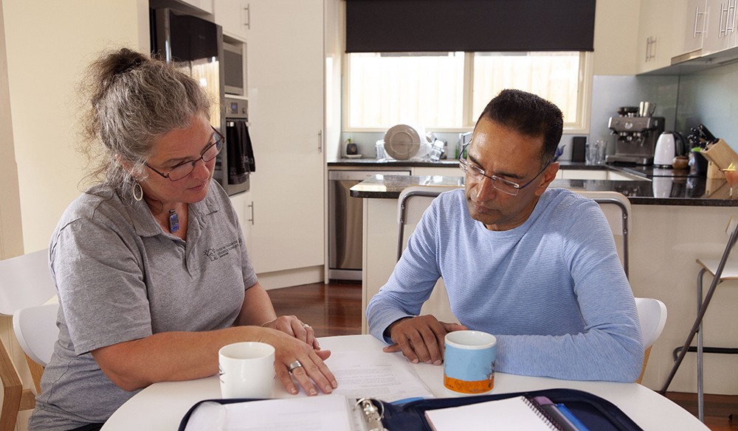

Further information about The Residential Efficiency Scorecard can be found on our website: homescorecard.gov.au
The team can be contacted via: scorecard@deeca.vic.gov.au



